PLI/RPLI Calculations

Table of content

- New Business
- Incentive of Sales Forces
- Loan
- Revival
- Surrender
- Maturity/Survival
- Death
- Conversion
- Commutation and Reduced Paid up

Introduction
Postal Life Insurance
Postal Life insurance was started in the year 1884. The Scheme initially had a limited offer as a welfare measure to post and telegraph employees and the extended to the employees of various departments of Central and State Government.
Types of PLI policies
- Whole Life Assurance (Suraksha)
- Convertible Whole Life Assurance (Suvidha)
- Endowment Assurance (Santosh)
- Anticipated Endowment Assurance (Sumangal)
- Joint Life Assurance (Yugal Suraksha)
- Children’s Policy (Bal JeevanBima)
RuralPostal Life Insurance
The Rural Postal Life Insurance Scheme launched on 24.3.1995 to cover Rural Public. The Scheme is operated as per the Notification issued by the Govt. of India vide ‘Rural Postal Life Insurance Schemes 1994.
Types of RPLI policies
- Whole Life Assurance (Gram Suraksha)
- Convertible Whole Life Assurance (Gram Suvidha)
- Endowment Assurance (Gram Santosh)
- Anticipated Endowment Assurance (Gram Sumangal)
- Ten Years RPLI (Gram Priya)
- Children’s Policy (Bal JeevanBima)
“Premium” means the periodical payment for any policy.

- Premium Payments (First Year):-
1.1 Premium of first payment:-Calculation is based on premium table given in the Sankalan issued by PLI Directorate. All the premium tables (Product wise) attached herewith for reference & necessary action.
premium tables for PLI policies Appendix 5.xlsx
premium tables for RPLI policies Appendix 7.xlsx
Note: - In RPLI the maximum limit of sum assured with non-standard proof of age shall be Rs. one lac. The 5% extra premium will be loaded and policies with sum assured of more than 25000/- should be subject to usual medical examination. Also, any one taking policies worth or more than Rs. 25000/-(Sum assured)with non-standard proof of age shall not be beyond 45 years of age.
- First Payment:-
Post office users can generate new proposal quotes at the counter, based on product type, sum assured and age of the proponent for use of agent / proponent. The quote gives details of the amount of premium to be paid (based on frequency of premium payment i.e. monthly, quarterly, half yearly & annually) against the sum assured opted by proponent.
First Payment = Exact policy amount of premium.
Calculation:-
Amount | Debit/Credit | Transaction Type
1046 | Dr. | Initial amount for PLI proposal- Payments/adjustment
1046 | Cr. | Premium Receipt
 | Cr. | CGST-Collection on PLI Services
 | Cr. | SGST-Collection on PLI Services
 | Cr. | UTGST-Collection on PLI Services
 | Cr. | IGST-Collection on PLI Services

The proponent may deposit first premium for any number of months and admissible rebate shall be given for six (6) months and twelve (12) months or more advance deposit in Postal Life Insurance and for three (3) months, six (6) months and twelve (12) months or more advance deposit in Rural Postal Life Insurance. The amount of premium(s) shall be refunded to the proponent after deducting the medical examination fee, if the proposal is not accepted by the accepting authority (Rule 22 of POLI rules).
2.1The medical fee paid from POLI/RPOLI fund. When a proposal is not accepted after the proposer has been medically examined, within sixty days, a second medical certificate shall be obtained and the fee thereof shall be paid by the proposer if he is responsible for the delay, otherwise it shall be paid out of the Insurance Fund.(Rule 28 of POLI rules).
If, a fact regarding serious illness of the proposer or death occurring due to any serious disease in the family of the proposer after medical examination of the proposer comes to the light of the Postmaster General/Head of Division/ Postmaster/ Manager of CPC/Accepting Authority before acceptance of proposal, a fresh medical examination may be ordered at the cost of the Fund.(Rule 29 of POLI rules).
The proposal form may be handed over to the concerned Marketing Staff or Counter Assistant by the proponent along with the advance premium in Cash or Cheque.(Rule 20 of POLI rules).

  - Refund:-
2.2.1 Refund (When policy is rejected):- The exact amount of the paid premium will be refunded.
2.2.2 Refund (Policy issued but cancelled by customer in Free look period of 15 days):-
Refund amount for Customer =Initial Premium - (Proportionate Risk Premium + Stamp Duty (If Any) + Medical Examination Fees (If Any)).(Rule 30(1) of POLI rules).
For instance, if the initial amount is Rs.15150/-, stamp duty is Rs. 400/-, Medical fee payable is Rs.50/-, First year premium is Rs. 4981/-, then Non POSB disbursement credit is Rs.9719/-.
Amount | Debit/Credit | Transaction Type
15150 | Dr. | First Year Premium
50 | Cr. | Medical fee payable
4981 | Cr. | First Year Premium
400 | Cr. | Stamp Duty Charges
9719 | Cr. | NON POSB Disbursement Credit

Calculation:-
Refund amount for customer = 15150-4981-400-50=9719.

No claims: A full refund is contingent on the fact that no claims were made during the free look period.
Processing time: The refund is processed within 7 working days after the request is received and all required documentation is complete.

2.2.3 Refund (Policy issued but cancelled by customer after Free look period of 15 days):-
No refund is payable if the policy has been cancelled by customer after free look period. Provided that the premia is of not less 36 months.

2.2.4 Shortfall Payment:- If a customer paid the first premium in around the birth date, but the policy was approved by the CPC after the birth date then there will be shortfall of the payment due to change of premium value.

Calculation:-
For instance, if the customer paid the initial premium of Rs.1000/- on 17.01.2025, the birthdate of the customer is on 25.01.2025. But the policy has been approved after 25.01.2025, than the premium amount will be 1050/-. This Rs.50/- will be in suspense account and will be adjusted in 2nd premium amount of the customer.

3. Medical Fees (paid to Doctor):-
Medical fee is being paid from POLI/RPOLI fund. Accordingly the applicable medical fee based on the sum assured and age of the customer is charged against the appropriate HoA.
Sum Assured | Medical fee
Up to Rs. 10 lakhs | Rs. 50 per examination.
Above Rs. 10 Lakhs uptoRs. 20 Lakhs | Rs. 70 per examination.
Above Rs. 20 Lakhs | Rs. 120 per examination.
Revival cases | Rs. 150 per examination.

Note: -The validity of the medical certificate is 60 days.
If it is not accepted within that period second medical examination is to be done and it is bear by customer itself.
4. Agent Commission:-
(OM 28-03/2019-LI(1) dated 19.03.2025 of PLI Dte)
  - (New Policy premium payment):-PLI Incentive is based on the premium paying term and the incentive rates are being fixed by PLI Directorate time to time.
4.1.1 Payment (First payment done and policy approved) for PLI
Procurement Incentive on PLI:Premium of first 12 months of a PLI policy is procurement (first year) premium. The incentive payable on the procurement (first year) premium will be procurement incentive.

4.1.1.1 Procurement Incentive rate for PLI policies other than Anticipated Endowment Assurance (i.e. WLA, CWLA, EA, Children Policy and Yugal Suraksha):

Premium paying term | Incentive Structure
Up to and equal to 15 years | 4% of first year premium income
More than 15 years but less than or equal to  25 years | 10% of first year premium income
More than 25 years | 20% of first year premium income

Calculation:-
- For Instance if a policy type is other than the AEA, and premium paying term is upto and equal to 15 years and let procurement incentive is 1000 than incentive payable on the procurement is 40.

4.1.1.2Procurement Incentive rate for PLI Anticipated Endowment Assurance Policies:

Premium paying term | Incentive Structure
less than or equal to 15 years | 5% of first year premium income
with term beyond 15 years | 7% of first year premium income

(As per letter dated 25.06.2021)

Calculation:-
- For Instance if a policy type is AEA, and premium paying term is less than or equal to 15 years and let procurement incentive is 1000 than incentive payable on the procurement is 50.

4.1.1.3Procurement Incentive rate on PLI policy for Development Officer (DO): DO will be paid incentive @ 1% of total PLI new business premium (NBP) procured by Direct Agents attached to that DO.

4.1.1.4 Procurement Incentive for RPLI:-
For all types of RPLI policies, each category of sales force will get procurement incentive @ 10% of procurement premium.

Calculation:-
- For Instance if a policy is in RPLI, let procurement incentive is 1000 than incentive payable on the procurement is 100.
- DO will be paid procurement incentive @ 1% of total RPLI new business premium (NBP) procured by Direct Agents attached to that DO.
NOTE:-Procurement incentive at the rate prescribed above will be payable on PLI/RPLI policies in case of online/cash/pay policies.

    - Refund:-
4.1.2.1 Policy issued but cancelled by customer in Free Look Period of 15 days:-For both Postal Life Insurance (PLI) and Rural Postal Life Insurance (RPLI), if a customer cancels a policy during the free-look period, the agent's incentive is reversed.
Deduction from future earnings: A negative entry is passed to the agent's commission account. In the subsequent month's incentive calculation, the clawed-back amount is deducted from the agent's total incentive.
No claims:A full refund is contingent on the fact that no claims were made during the free look period.
Processing time:The refund is processed within 7 working days after the request is received and all required documentation is complete.
      - Policy issued but cancelled by customer after Free Look Period of 15 days:-
- When a policy is issued and the free-look period concludes, the agent has fulfilled their role in the initial sale and earned their commission.

- The agent may be required to refund the initial commission to the insurance provider, especially if the policy is surrendered shortly after issuance.

- This is enforced because an early surrender means the insurance company is receiving significantly less premium than initially expected, while the agent has already been paid their full first-year commission.

5. First year Premium (other than first payment):-

5.1 Payment (Timely)

5.1.1 Exact amount:-Same amount as of paid during first premium.
Amount | Debit/Credit | Tx Type
1046 | Dr. | Initial amount for PLI proposal- Payments/adjustment
1046 | Cr. | Premium Receipt
 | Cr. | CGST-Collection on PLI Services
 | Cr. | SGST-Collection on PLI Services
 | Cr. | UTGST-Collection on PLI Services
 | Cr. | IGST-Collection on PLI Services

5.1.2 Advance payment with rebate (may be single premium or multiple premiums):-
As per POLI Rule the system should be capable to provide the rebate on advance premia as per below calculation:-
In case of policies where premia are payable on monthly basis, the insurant may pay premia for a number of months in advance to avail the facility of rebate:
- A rebate @2% shall be allowed if the premia for 12 months are paid in advance.
- A rebate @1% shall be allowed if the premia for 6 months are paid in advance.
- Similarly, a rebate of 0.5% shall be allowed in RPLI, if the premia for 3 months are paid in advance.
    - Additional Rebate :-For every 20,000/- sum assured, a rebate of Rs. 1 is allowed every month in EA/WLA/AEA policies.

5.1.4 Advance payment without rebate:-
No rebate will be payable to the insurant if the premia is payable for less than 6 months for PLI and 3 months for RPLI policies.
Note- The insurant can pay the premium in the subsequent month, by paying a minimum fine of 1% of the premium amount per month.

5.2 Payment (Late Payment):-
5.2.1 Exact amount:-The amount of premium that remains unpaid after the due date within the grace period making the policy lapsed, if not paid in due time.
Calculation: - Customer can pay the premium in the subsequent month, by paying a minimum fine of 1% of premium amount per month.
- N*(N+1)* Premium/200
- No. of default*Premium/100
Note: - N= No. of Months
5.2.2 Advance Payment with Rebate (may be single premium or multiple premiums):-
If the customer pays the premium amount for six months for PLI and three months for RPLI and more, than the insurant is eligible for rebate along with the default fee for the subsequent month premium payment.

5.2.3 Advance Payment without Rebate (may be single premium or multiple premiums):-
If the customer pays the premium amount for less than six months for PLI and three months for RPLI than the insurant is not eligible for rebate. The default fee will be payable for the subsequent month premium amount.

Note*- The calculation of the rebate (refer 5.1.2 & 5.1.3) and default fee (refer 5.2.1) is same as above.
Example of premium calculation with rebates:-
- Monthly Premium:
If the monthly premium is ₹1,250 and you are eligible for a ₹25 monthly rebate, your actual monthly payment is ₹1,225.
- Quarterly Premium:
If the quarterly premium is ₹3,600 and you are eligible for a ₹75 rebate, your actual quarterly payment is ₹3,525.
- Half-yearly Premium:
If the half-yearly premium is ₹7,075 and you are eligible for a ₹150 rebate, your actual half-yearly payment is ₹6,925.
- Yearly Premium:
If the yearly premium is ₹13,675 and you are eligible for a ₹300 rebate, your actual yearly payment is ₹13,375.

Agent Incentive amount calculation is as stated above (refer 4.1.1).

- Premium Payment (Renewal):-

6.1 Policy payment (Timely or Late payment):-
6.1.1 Exact amount = same amount as of paid during first premium.
6.1.2 Advance payment with Rebate and without rebate (may be single premium or multiple premiums):-
Calculation for renewal premium without rebate will be same as the initial premium calculation. (refer 5.1 & 5.2)

7. Agent Incentive for Renewal Premium Payment:-

7.1 A.Premiumreceivedfrom13thmonthonwardsinaPLIpolicyisrenewalpremium. Renewal Incentive on PLI policies procured between 01.10.2009 to 31.03.2017:–
Category of Sales force | 01.10.2009 till  31.03.2017 | 01.04.2017 till  30.06.2020 | On or after 01.07.2020
Departmental Employees | Nil | 2% of renewal premium | 1% of renewal premium
Field Officer | 2% of renewal premium | 2% of renewal premium | 1% of renewal premium
DirectAgents | 2% of renewal premium | 2% of renewal premium | 1% of renewal premium
GraminDakSevaks | Nil | 2% ofrenewal premium | 1% of renewal premium

B.Renewal IncentiveonPLIpoliciesprocuredbetween01.04.2017to30.06.2020: –
CategoryofSalesforce | 01.04.2017 to 30.06.2020 | On orafter 01.07.2020
DepartmentalEmployees | 2%ofrenewalpremium | 1%ofrenewalpremium
Field Officer | 2%ofrenewalpremium | 1%ofrenewalpremium
DirectAgents | 2%ofrenewalpremium | 1%ofrenewalpremium
GraminDakSevaks | 2%ofrenewalpremium | 1%ofrenewalpremium

C.RenewalIncentiveonPLIpoliciesprocuredOn orafter01.07.2020:–
CategoryofSalesforce | On orafter 01.07.2020
DepartmentalEmployees | 1%ofrenewalpremium
Field Officer | 1%ofrenewalpremium
DirectAgents | 1%ofrenewalpremium
GraminDakSevaks | 1%ofrenewalpremium

  - ProcurementIncentiveonRPLI:
    - Premiumoffirst12monthsofaRPLIpolicyisprocurement(firstyear)premium.The incentive payable on the procurement (first year) premium will be procurement incentive.

    - For all types of RPLI policies, each category of sales force will get procurement incentive @10% of procurement (first year) premium.

  - RenewalIncentiveonRPLI:
    - Premiumreceivedfrom13thmonthonwardsinaRPLIpolicyisrenewalpremium. The incentive payable on renewal premium will be renewal incentive.

    - RenewalIncentiveonRPLIpoliciesprocuredonorafter01.10.2009–
CategoryofSalesforce | On orafter 01.10.2009
DepartmentalEmployees | 2.5%ofrenewalpremium
Field Officer | 2.5%ofrenewalpremium
DirectAgents | 2.5%ofrenewalpremium
GraminDakSevaks | 2.5%ofrenewalpremium

  - DOwillbepaidincentive@0.7%ofPLI&RPLIfirstyearpremiumprocuredbyallDirect Agents attached to that DO.
Note-(i) Renewal incentive at the rate prescribed above will be payable on PLI/RPLI policies in case of online/cash policies. No renewal incentive will be payable in case of pay policies.

Loan:-
The loan may be repaid at any time. It may also be paid in installments of amount not less than Rs. 100/-. Interest will be charged @ 10% per annum compounding half yearly from the date of disbursement of loan and should be paid on or before the dates specified in the loan bond and loan repayment receipt book. Interest for the half year will be charged on the amount outstanding on the first day of the half year, and any repayment made during that half year will be taken into account for calculation of interest only for the next half year. In the case of final repayment, interest will not be charged beyond the last date of the month in which the final repayment is made provided that interest had already been charged on the loan for at least six months. The responsibility for payment of interest rests solely on the insurant. A notice regarding the amount to be paid as half yearly interest will be issued to the insurant only when there is a change in the amount payable as interest as a result of payment of a part of the principal.
But the plea of non-receipt of such a notice cannot in any circumstances be accepted for non-payment of interest. If the interest is not paid on the due date, it will be added to the outstanding amount of loan and usual interest charged thereon. (POLI Rule 59(3))
Loan Sanction Example:
The following are the details of a Policy Number 1234 and Policyholder A.
Product Name: Suraksha Issue Date : 25/11/2000
Policy Years: 12 years Surrender Value : 14,000 Rs.
Loan Application Date: 27/11/2012
So as of Loan Application date the policyholder A is eligible for 90% of Surrender Value.
Maximum Loan Amount: 90% of Rs.14, 000 = Rs.12, 600
Minimum Loan Amount: Rs. 1000.
Thus a policyholder A will be eligible for Loan Amount between Minimum Loan Amount and Maximum Loan Amount.
Loan Closure
The Process :- Loan Interest amount has to be paid as per the Repayment Schedule given in Loan Bond.
• The loan interest payment has to be paid once every 6 months. In case when Loan interest is not repaid within the due date the outstanding loan interest is capitalized in case of non-payment of loan interest.
• On three consecutive defaults in Interest payment against loan, the policy shall be surrendered.
• Currently any loan repayment is registered in the Loan repayment receipt book. In case of ad-hoc repayments the Repayment schedule is revised and interest on the Outstanding Loan amount is calculated in next six monthly cycle.
• All the repayment details are updated in Loan Repayment receipt book.
Loan Calculations
• Policy loan is calculated as a percentage of surrender value.
• Maximum loan amount applicable shall be 90% of surrender value provided the policy age has exceeded 12 years.
• The Loan interest rate is 10%, subject to change in future.
Example: Loan Interest Calculation:
Loan Interest Rate: 10 %
Loan Amount: Rs. 1000.
Loan Interest to be calculated six monthly once:
A = P (1 + r/n) (n) (t)
A is the Final Amount
P is the Principal Amount
r is rate of interest
n is the number of compounding periods
Based on this formula the Loan Interest Amount for half year shall be Rs. 512.

Product Type | Product Name | Currency of surrender value admissible | Percentage of surrender value admissible
Whole Life Assurance (WLA) | Suraksha and Gram Suraksha | More than 4 years to 7 years  More than 7 years to 12 years  More than 12years | 60%  80%  90%
Endowment Assurance (EA) and Convertible Whole Life Assurance (CWLA) | Santosh, Gram Santosh, Suvidha, Yugal Suruksha | More than 3 years to 5 years  More than 5 years to 10 years  More than 10 years | 60%  80%  90%

Revival of lapsed Policy:-(Customer Portal of India post)
If the premia are not paid for 6 months in case of policy within 3 years, (or) 12 months in case of policy more than 3 years, then the policy becomes lapsed. This needs revival to make it active. Revival may be on any number of occasions during entire term of the policy, provided a period of consecutive 5 (five) years should not have passed from the date of first unpaid premium. After credit of due premium with interest @12% per annum and a good health certificate, the policy can be revived. Revival amount may be paid in one lump sum or in convenient installments not exceeding 12 installments.
Application for Revival - may be obtained from nearest Post Office/CPC or may be downloaded from India Post website, PLI website or PLI Customer Portal
Correct and complete filling up of Application for Revival supported with Medical Certificate in prescribed performa.
Submission of duly filled-in Application for Revival, along with all relevant documents, at any Post Office/CPC
Revival period and conditions:-
The rules for reviving a lapsed PLI policy are based on the duration of non-payment from the first missed premium.
Provide an employer certificate confirming no medical leave was taken during the lapsed period (if applicable).
- Important note: Policies that lapsed for a continuous period of five years from the date of the first unpaid premium became ineligible for revival after January 1, 2020, as per the Post Office Life Insurance Rules, 2011.
Revival procedure:-
- Obtain the revival application form: Contact the nearest Post Office or download the form from the India Post website.
- Fill out the application: Complete the form with your personal and policy details, including the period and reason for non-payment.
- Gather required documents: This includes the application form, medical certificate, employer certificate, and your premium receipt book.
- Pay arrears: Calculate and pay the total outstanding premiums plus the 12% per annum interest. You can also inquire about the possibility of paying the revival amount in installments.
- Submit documents: Submit your application and documents to the Post Office where you intend to resume premium payments.
- Medical examination (if required): Depending on the duration of the lapse, a medical examination by an authorized doctor may be required to prove good health.
- Department review: The Department of Posts will review the application and medical reports before approving the revival.
- Receive confirmation: Once approved, your policy will be reinstated, and you will receive confirmation. The due bonus will be automatically attached to your revived policy.
Calculation formulae for Interest:
Different formulae for revival and reinstatement as per DoP response during BPD Sessions:
Revival Interest: [{(1.01)ⁿ - 1} * 101] * Premium
(n= number of monthly premium to be paid).
Reinstatement Interest: {N*(N+1)*P} ÷ 200
(N = Number of monthly premium to be paid).
Interest should not be charged for ‘Pay Deduction Policies’ if the schedule comes after the grace period.
Illustrations: (As received from DoP PLI during BPD sessions)
Revival of Policy
Premium Amount= Rs.650 per month
Number of monthly instalment premiums due=23 months
Revival Amount= [{(1.01)ⁿ - 1} x 101 ] x P
= {(1.25716301826 – 1) x 101} x 650
=16882.75 i.e 16883 (Rounded-off to nearest rupee)
Premium = Rs. 14,950
Interest= Rs. 1932.75 i.e Rs.1,933
For above case Instalment Revival Calculation:
Example in 4 instalments
Reinstatement Calculation:
Premium Amount= 650 per month
Number of months = 23
Reinstatement Interest Formula= {N*(N+1)*P} ÷ 200
(23 x 24 x 650) ÷ 200
For RPLI policies “Employer Certificate” is not a mandatory requirement for Revival/Reinstatement.
Validity of Revival Approval is to be made configurable in the system as 30 Days, 45 Days, 60 Days. Policy Status to be changed to "Revival Approved" upon approval of revival. Same can be reverted to lapse on expiry of Validity of Revival.
In case the Revival/Reinstatement amount comes after the validity period of quotation expires, the Revival/Reinstatement amount should be re-calculated. Validity of a revival quotation is up to the last working day of the month since the revival interest calculation formula is based on “Monthly” frequency.
In case of the premium not paid for XX months - automatic termination of policy:
Surrender of Policies:-
A policy other than an Anticipated Endowment Assurance, 10 Year Rural PLI and Children policy may be surrendered for an immediate payment in cash, provided the policy is of not less than three years duration. In such a case, the insured person or the assigns of the policy, as the case may be, shall give notice of surrender, in writing, to the Postmaster/Manager of Central Processing Centre (GPO/Head Office) concerned and forward the policy or a duplicate copy thereof or Indemnity bond (if policy is lost) at any Post office along with the premium receipt book, if premia had been paid in cash and loan repayment receipt book, if loan principal/interest is outstanding. The concerned Post Office will send all those documents to the Postmaster/ Manager of Central Processing Centre (GPO/ Head Office) from where the same will be sent to the concerned approving authority for approval.
For policies in respect of which premium is paid annually in advance, surrender value is to be calculated at the end of the year irrespective of the date of surrender but payment of surrender value may be made when the policy holder asks for it. No bonus will be paid in respect of a policy with effect from the date of discontinuance of premia. Proportionate bonus shall be paid on paid up value after completion of 5 years i.e. if a policy remains in force at least for 5 years. (Rule 55 of POLI Rules)

Calculation of refund to the customer (Surrender Value):-

- The refund to the customer is known as the surrender value, which is based on the premiums paid and the duration the policy was active.
- Surrender facility is available after 3 years in case of WLA, EA, CWLA and YS (for PLI) and WLA, EA, CWLA and GY (for RPLI) policies. No surrender facility is available in case of AEA and Children policy. Surrender value depends on the surrender factor, type and term of policy. Surrendering any policy is always a loss. Bonus on the reduced sum assured is paid only if the policy is surrendered after 5 years.(India Post Customer Portal)

- Bonus payment: -
< 5 Yrs Policy age- Nil
>5 Yrs Policy age- proportionate to the reduced Sum Assured.
No bonus to be paid after discontinuance of payment.

- Formula for surrender value:-
Surrender Value= (Paid-up value+ Bonus)*Surrender factor (Ref: Surrender factor table)-Unpaid premium-Unpaid loan principal and interest

Where:
Paid-up Value: A reduced sum assured based on the premiums paid.

Paid-up Value = (Sum Assured amount* Total number of Premium Paid)/Total number of premium payable

- Surrender Factor: - A pre-determined percentage that varies based on the policy type and the number of years premiums have been paid. The factor increases with the policy's duration.

- Proportionate Bonus: - Any bonus that has accrued. However, if the policy is surrendered between the third and fifth year, no bonus is paid.

- Bonus Calculation on paid-up amount= Bonus rate* Paid up value)/1000

- Calculations for PLI Surrender:-

Scenario:-

PLI Surrender
Age at entry= 19 | Age at Maturity= 35 | Sum Assured= 100000
Period of Premium: 35-19=16 | Date of Birth= 01.11.1994 | Date of entry= 31.10.2013
If surrender being made after three years and less that 5 years | Date of surrender= 31.10.2016 | Attended Age= 22
Paid up value= (Sum Assured amount* Total number of Premium Paid)/Total number of premium payable= 100000*36/192= 18750/-
Surrender factor at the age 22 under EA/35= 0.533
Surrender Value= (Paid-up value+ Bonus)*Surrender factor (Ref: Surrender factor table)-Unpaid premium-Unpaid loan principal and interest

** Bonus will not be paid as the policy could not continued for 60 months

*** Surrender Value= 18750*0.533= 9993.75 i.e. 9994/-

Scenario:-

If surrender being done after continuation of 5 years
Age at entry= 19 | Age at Maturity= 35 | Sum Assured= 100000
Period of Premium: 35-19=16 | Date of Birth= 01.11.1994 | Date of entry= 31.10.2013
If surrender being made after three years | Date of surrender= 31.10.2019 | Attended age= 25
Paid up value= (Sum Assured amount* Total number of Premium Paid)/Total number of premium payable= 100000*72/192= 37500/-
Surrender factor at the age 25 under EA/35= 0.616
Bonus for 2013-14 to 2018-19= 58*6= 348 | Bonus= 37500*348/1000= 13050
Surrender Value= (Paid-up value+ Bonus)*Surrender factor (Ref: Surrender factor table)-Unpaid premium-Unpaid loan principal and interest

*** Surrender Value= (37500+13050)*0.616= 31138.80 i.e. 31139/-

- Calculations for RPLI Surrender:-

Scenario:-

RPLI Surrender
Age at entry= 19 | Age at Maturity= 35 | Sum Assured= 100000
Period of Premium: 35-19=16 | Date of Birth= 01.11.1994 | Date of entry= 31.10.2013
If surrender being made after three years and less that 5 years | Date of surrender= 31.10.2016 | Attended Age= 22
Paid up value= (Sum Assured amount* Total number of Premium Paid)/Total number of premium payable= 100000*36/192= 18750/-
Surrender factor at the age 22 under EA/35= 0.533
Surrender Value= (Paid-up value+ Bonus)*Surrender factor (Ref: Surrender factor table)-Unpaid premium-Unpaid loan principal and interest

** Bonus will not be paid as the policy could not continued for 60 months

*** Surrender Value= 18750*0.533= 9993.75 i.e. 9994/-

Scenario:-

If surrender being done after continuation of 5 years
Age at entry= 19 | Age at Maturity= 35 | Sum Assured= 100000
Period of Premium: 35-19=16 | Date of Birth= 01.11.1994 | Date of entry= 31.10.2013
If surrender being made after three years | Date of surrender= 31.10.2019 | Attended age= 25
Paid up value= (Sum Assured amount* Total number of Premium Paid)/Total number of premium payable= 100000*72/192= 37500/-
Surrender factor at the age 25 under EA/35= 0.616
Bonus for 2013-14 to 2019-20= 50*6= 300 | Bonus= 37500*300/1000= 11250
Surrender Value= (Paid-up value+ Bonus)*Surrender factor (Ref: Surrender factor table)-Unpaid premium-Unpaid loan principal and interest

*** Surrender Value= (37500+11250)*0.616= 30030/-

Surrender Factor Table PLI (EA)
Surrender Factor Table PLI (WLA)
Surrender Factor Table PLI (YS)
Surrender Factor Table RPLI (EA)
Surrender Factor Table RPLI (WLA)

Maturity/Survival:-
- General Rules- All the maturity and Survival claims in respect of policies of such persons shall be settled in Indian currency in accordance with Post Office Life Insurance Rules.

- Maturity- In a postal life insurance, maturity refers to the completion of the policy’s term and the date on which the policyholder receives the final payout, which includes the sum assured plus accrued bonus, provided all premiums have been paid.

- Survival Claim– It means a life insurance contract entered into by Government to pay a given sum of money, in stipulated installments, to an individual or his assignee, on survival to the end of specified periods, or to pay the given sum of money in one lump sum to his legal representatives or assigns on his death, if death occurs before the specified date of maturity.

- Auto Paid Up

"Auto paid up" means a policy for which 36 or more premiums have been paid and also has completed three years or more duration from its date of acceptance and the policy holder without intimation discontinues payment of further premia. However, the policy shall be maturing on the same date as the original policy, either for the original sum assured, when the future premiums payable are compounded by a single payment, or for a reduced sum assured, when the premium in respect of the original policy are discontinued before the stipulated term.

- Paid Up Policies
"Paid up Policy" means a policy which requires no further payment of premium in respect of it, but maturing at the same date as the original policy, either for the original sum assured, when the future premiums payable are compounded by a single payment, or for a reduced sum assured, when the premium in respect of the original policy are discontinued before the stipulated term.

- Maturity Benefit for Reduced Paid Up policies
In the event of cessation of premium before maturity age, the reduced paid up assurance will be granted, provided premiums have been paid for not less than three years, only at the date of maturity, that is at the end of stipulated plan term.

- Survival Benefit Pay-out for Reduced Paid Up policies
In case of Survival benefit, if the policy has become reduced paid up, in that case no further periodical payments on account of survival benefit will be paid. At the end of the period, the reduced sum assured will be paid along with the bonus accrued.

- Delay in Policies–
If the claim is not settled within 30 days from the actual date of receipt of complete claim papers, it is established that the delay in the payment of claims was attributable to administrative delays, ex-gratia payment of interest at the rate of 8% per annum on the unsettled amount of claim shall be paid for the delay beyond this period.

- Benefit Calculation - Product wise :

PLI Products:

Suraksha- Whole Life Assurance | SA + Bonus
Santosh-Endowment Assurance | SA + Bonus
Suvidha - Convertible Whole Life Assurance | SA + Bonus
Sumangal - Anticipated Endowment Assurance | Paid to the insured - periodically -For the 15 years term policy, the benefits are paid after 6 years (20%), 9 years (20%), 12 years (20%) and 15 years (40% and the accrued bonus). -For the 20 years term policy, the benefits are paid after 8 years (20%), 12 years (20%), 16 years (20%) and 20 years (40% and the accrued bonus). -Such payments will not be taken into consideration in the event of unexpected death of the insurant and the full sum assured with accrued bonus is payable to the assignee or legal heir
Yugal Suraksha - Joint Life Assurance | SA + Bonus is paid on survival of both the insured (self & spouse)
Children Policy | SA + Bonus

RPLI Products:

Gram Suraksha- Whole Life Asusrance | SA + Bonus
Gram Santosh-Endowment Assurance | SA + Bonus
Gram Suvidha - Convertible Whole Life Assurance | SA + Bonus
Gram Sumangal - Anticipated Endowment Assurance | Paid to the insured - periodically -For the 15 years term policy, the benefits are paid after 6 years (20%), 9 years (20%), 12 years (20%) and 15 years (40% and the accrued bonus). -For the 20 years term policy, the benefits are paid after 8 years (20%), 12 years (20%), 16 years (20%) and 20 years (40% and the accrued bonus). -Such payments will not be taken into consideration in the event of unexpected death. of the insurant and the full sum assured with accrued bonus is payable to the assignee or legal heir
Gram Priya (Ten year term plan) | Survival benefit is payable as under  • At the end of 4 years - 20%  . At the end of 7 years - 20%  At the end of 10 years -60% with accrued bonus
CHILDREN POLICY -Rural Postal Life Insurance Scheme | SA + Bonus
Scheme for Physically handicapped persons | •: SA + Bonus

Remission Period for Policies within thirty six months in case of premium/premia due
If the policy life is within thirty six months acceptance of the policy and where any premium/premia have become due, not paid either on first day of the month for which the premium is due or within the period of grace allowed
The policy shall become void and all claims to any benefit in virtue thereof shall cease and all money that have been paid in consequence thereof shall be forfeited EXCEPT
• Cases like if an insured person is not to be considered as in arrears of premium for any months so long as he has not been able to draw his pay, pension. or subsistence allowance during suspension, or if the insured person is on leave in India or any leave allowance though due for the month next before it is due or due to circumstances beyond his control
There is provision called "remission period" allowed based on the policy life.
Policy Life | Remission Period allowed
< 6 months | Nil
>6 months but less than 12 months | LO+30 days
>12 months but less than24 months | LO+60 days
>24 months but less than 36 months | LO+90 days

Where LO is the grace period on the policy.
Remission Period for Policies beyond thirty six months in premium/premia due
If Policy Life is more than 36 months then remission period allowed is Date the first unpaid premium +12months case of After the remission days, policy is said to be lapsed completely and sum assured will be adjusted accordingly.
Maturity Claim Calculation
Gross Amount payable = Base Sum Assured + Accumulated Bonus +Interest applicable + Excess premiums
Gross Deductions= Loan Outstanding+ Unpaid Charges and Fees+ Unpaid premiums
Net amount payable = Gross Amount Payable-Gross Deductions
Payee Details
If no assignment is made, system displays the Insured name as the payee.
If the Policy is assigned - When the Policy is under Absolute/Conditional Assignment then the Assignees Name Appears under the Payee Tab.
If there is no Assignment and the Policy is under MWP or HUF then the payee details are updated with the Trust Name
Calculation:-
Scenario:-
PLI Maturity (EA)
Age at entry= 30 | Age at maturity= 35 | Sum assured= 100000
Date of Birth= 01.11.1983 | Date of entry= 31.10.2013 | Bonus rate: 2013-14 to 2017-18 was 58
Bonus paid= 100000*58*5/1000= 29000 | Total Amount Payable= 100000+29000= 129000

PLI Maturity/Survival (AEA)
Age at entry= 30 | Age at maturity= 45 | Sum assured= 100000
Date of Birth= 01.11.1980 | Date of entry= 31.10.2010 | Bonus rate:  2010-11 = 55*1  2011-12 to 2019-20= 53*9  2020-21 to 2024-25= 48*5
First 20% (20000) in 2016 | Second 20% (20000) in 2019 | Third 20% (20000) in 2022
Bonus paid: 100000*(55+477+240)/1000= 77200 | Total amount payable= 40000+77200= 117200

RPLI Maturity (EA)
Age at entry= 30 | Age at maturity= 35 | Sum assured= 100000
Date of Birth= 01.11.1983 | Date of entry= 31.10.2013 | Bonus rate: 2013-14 to 2017-18 was 50
Bonus paid= 100000*50*5/1000= 25000 | Total Amount Payable= 100000+25000= 125000

RPLI Maturity/Survival (GY)
Age at entry= 30 | Age at maturity= 40 | Sum assured= 100000
Date of Birth= 01.11.1980 | Date of entry= 31.10.2010 | Bonus rate: 2010-11 to 2019-20 was 47
First 20% (20000) in 2014 | Second 20% (20000) in 2017
Bonus paid= 100000*47*10/1000= 47000 | Total amount payable= 60000+47000= 107000/-

Death claim
Business Rules
Following are the PLI and RPLI products for which the death claim is applicable.

Postal Life Insurance:
1. Whole Life Assurance (SURAKSHA)
2. Convertible Whole Life Assurance (SUVIDHA)
3. Endowment Assurance (SANTOSH)
4. Anticipated Endowment Assurance (SUMANGAL)
5. Joint Life Assurance (YUGAL SURAKSHA)
6. Scheme for Physically handicapped persons
7. Children Policy

Rural Postal Life Insurance:
1. Whole Life Assurance (GRAMA SURAKSHA)
2. Convertible Whole Life Assurance (GRAMA SUVIDHA)
3. Endowment Assurance (GRAMA SANTOSH)
4. Anticipated Endowment Assurance (GRAMA SUMANGAL)
5. GRAM PRIYA
6. Scheme for Physically handicapped persons

Documents to be submitted at the time of death claim
The documents to be submitted along with the Death claim application form are:

- Policy Bond
- Premium Receipt Book
- Attested copy of death Certificate
- Attested copy of Post-mortem report
- Copy of FIR in case of unnatural death
- Report of the doctor who last attended the deceased, if available

Only one unique Row per document will be created by the system

Death claim General Rules
All the death claims in respect of policies of such persons shall be settled in Indian currency in accordance with Post Office Life Insurance Rules.

Early Death claim
Early death is the death which occurred before completion of 3 years from the date of Acceptance of a policy and it will be investigated thoroughly.
If a Policy has been in force for less than 3 years then the system sends the Policy for Investigation.
Death by suicide
In the event of an insured person committing suicide any time after the date of acceptance of the policy (whether sane or insane at that time) and after having paid his first premium in full but not after expiry of two years from such date of acceptance or payment of first premium whichever is later, the policy shall become void and no claim whatsoever shall be entertained by the department
When the death is notified with a status of Suicide on the Claim notification screen Under "Category". The system makes the policy status as Void and does not allow further processing of the claim
If the Policy is more than two year on the date of death of the insured and policy issue date then the system registers the claim and allows normal processing.
For policies with sum assured Rs 1,00,000/- without nomination
Death Claim for an amount of up to INR 1, 00,000/- (one lakh only), where no nomination exists, The production of succession certificate may be waived by the Director General of Posts, provided the case is recommended by the Postmaster General concerned on valid grounds. After waiver, the case shall be settled by Postmaster General observing usual formalities.
(The finale authority to waive the production of succession certificate should be configurable by the System Manager looking after the main server.)
For policies with Sum Assured of over 100000 INR where Nominee/Assignee information is not available system defaults a row in the Document Table on the Capture Document Screen (Refer section 7.1.3 of this document. The succession certificate will be mandatory screen exit rule for the claim Handler. However the Claim Approver (both at DO and the Directorate will be able to exit the screen even without the receipt of this document.
If the policy holder is murdered by legal representative/Nominee
If the policy holder is murdered by any of the legal representative/nominee(s), the policy money shall not be paid to the murderer even if he/she is acquitted by the competent court of law by giving him/her the benefit of doubt.
If the policy is not reinstated at the event of death
No claim, whatsoever shall lie on the department in the event of death of the life assured taking place during such period when premium are held in suspense and the policy is not re-instated. Such premium as are held in suspense shall be refundable to the policy holder, his/her nominee or his/her legal heir as the case may be, as and when applied for.
Policy with prior loan existing on it
If any loan exists on the policy, the outstanding balance of the loan with interest will be recovered from the value of the policy at the time of settlement of the claim.
Policy with premium held in suspense account
When premia are held in suspense and the policy is not re-instated .No claim shall lie on the department in the event of death of the life assured taking place during such period. Such premia as are held in suspense shall be refundable to the nominee or his/her legal heir as the case may be, as and when applied for.
Policy with absolute assignment
In the case of an absolute assignment, all rights of the assured are vested in the assignee by an assignment and the assigns may therefore be entitled to claim the surrender value of the policy without Policy owner's consent.
Cases with recommending bad lives
Cases of recommending bad lives by Registered Medical Practitioners and consequential premature Death claims within three years from the date of acceptance, a proper record of RMPS (Full name, permanent address, name of clinic, date of authorization Policy No in respect of which premature death claim was received with sum assured and cause of death etc.) should be kept by the Postmaster General for review of authorization after two years. Any adverse report should be taken notice of for his decision.
Settlement of claim on death with nomination
The policies with nomination on them should be settled within 15 days of intimation. The likely
Death claim calculation
Non-Medical Cases
Upon the verification of the submitted documents, the claimant is eligible to get the Death benefit amount as prescribed in the below table. Here the Death claim Payout is dependent variable on the Policy life (in years).
Policy Life | Death Claim Payout
<1 yr | 35% SA + accrued Bonus
1-2 yrs | 60% SA + accrued Bonus
2-3 Yrs | 90% SA + accrued Bonus
>=3 Yrs. | 100% SA + accrued Bonus

Medical Case
Sum Assured plus all accrued Bonuses will be paid out on death
Policies within thirty six months and settlement of death claims in case of premium/ premium due
If, in the case of a policy where death takes place before the completion of thirty six months from the date of acceptance of the policy and where any premium/premia have become due, not paid either on first day of the month for which the premium is due or within the period of grace allowed the policy shall become void and all claims to any benefit in virtue thereof shall cease and all money that have been paid in consequence thereof shall be forfeited EXCEPT
- Cases like if an insured person is not to be considered as in arrears of premium for any months so long as he has not been able to draw his pay, pension.
- or subsistence allowance during suspension, or if the insured person is on leave in India
- or any leave allowance though due for the month next before it is due
- or due to circumstances beyond his control
Otherwise, if the death occurred within the thirty six months, there is remission period allowed based on the policy life.
Policy Life | Remission Period allowed
< 6 months | Nil
>6 months but less than12 months | LO+30 days
>12 months but less than24 months | LO+60 days
>24 months but less than36 months | LO+90 days

Where LO is the grace period on the policy.
Policies beyond thirty six months and settlement of death claims in case of premium/premia due
If Death occurred on Policy Life is more than 36months then remission period allowed is Date the first unpaid premium+12months
After the remission days, policy is said to be lapsed completely and sum assured will be adjusted accordingly.
Note: If within the above said period of twelve months the policy does not become a claim either due to the death of the life assured or on completion of term of the policy and if no application for surrender value or for making the policy paid up policy is received within that period, the policywill be automatically kept alive only to the extent of its paid up value provided such paid up value is not less than Rs. 10,000/-
Delay in Payments
For more than 60 days, from the actual date of receipt of complete claim papers in the case of death claim under policies where no investigation is required.
It is established that the delay in the payment of claims was attributable to administrative delays additional payment of interest at the rate of 8% per annum on the unsettled amount of claim shall be paid.
Orders for Payments
The orders for payment of the amount of death claim shall be issued to the concerned Postmaster, under intimation to the claimant. The amount sanctioned shall be paid to the claimant on his surrendering the payee's copy (on the Postmaster's copy if the payees copy is lost and an endorsement shall be made to this effect duly signed by the payee with witness) of the order at the Post Office and signing a receipt for it, duly stamped, where necessary, on the back of the order.
Postal Life Insurance:
Whole Life Assurance (SURAKSHA)
Convertible Whole Life Assurance (SUVIDHA)
Endowment Assurance (SANTOSH)
Anticipated Endowment Assurance (SUMANGAL)
Joint Life Assurance (YUGAL SURAKSHA)
Scheme for Physically handicapped persons
Children Policy
Rural Postal Life Insurance:
Whole Life Assurance (GRAMA SURAKSHA)
Convertible Whole Life Assurance (GRAMA SUVIDHA)
Endowment Assurance (GRAMA SANTOSH)
Anticipated Endowment Assurance (GRAMA SUMANGAL)
GRAM PRIYA
Scheme for Physically handicapped persons

Calculation for Death Claim Case:-
Scenario:-
Death Claim Case PLI (EA)
Age at entry= 30 | Age at maturity= 35 | Sum Assured= 100000
Date of Birth= 01.11.1993 | Date of entry= 03.04.2023 | Bonus rate= 2023-24 i.e. 52
Date of Death= 07.11.2023 | Premium paid from April 2023 to November 2023
Bonus paid= 100000*52*1/1000= 5200 | Total Amount payable= 100000+5200= 105200/-
In case of Non Medical Policy | 01-12 months= 35% of Sum Assured amount+ Accrued Bonus  13-24 months= 60% of Sum Assured amount+ Accrued Bonus  25-35 months= 90% of Sum Assured amount+ Accrued Bonus  36 months and above= Total Sum Assured amount+ Accrued Bonus

Scenario:-
Death Claim Case RPLI (EA)
Age at entry= 30 | Age at maturity= 35 | Sum Assured= 100000
Date of Birth= 01.11.1993 | Date of entry= 03.04.2023 | Bonus rate= 2023-24 i.e. 48
Date of Death= 07.11.2023 | Premium paid from April 2023 to November 2023
Bonus paid= 100000*48*1/1000= 4800 | Total Amount payable= 100000+4800= 104800/-
In case of Non Medical Policy | 01-12 months= 35% of Sum Assured amount+ Accrued Bonus  13-24 months= 60% of Sum Assured amount+ Accrued Bonus  25-35 months= 90% of Sum Assured amount+ Accrued Bonus  36 months and above= Total Sum Assured amount+ Accrued Bonus

Conversion
- This functionality provides policy owner facility to change the product during the lifetime of the policy.
- “Conversion” means any alteration affecting the date of maturity of a contract of insurance and includes not only alteration from Whole Life Insurance class to the Endowment class but also the antedating or postdating of the maturity of an Endowment policy and consequent increase/decrease of premium.
- Conversion of commutation of a policy other than CWL class to an EA class payable at the ages of 30, 33, 35, 40, 45, 50, 55, 58 and 60 only will be admissible.
- Conversion of policy as would put the date of maturity or the date of cessation of premium to a date preceding or within one year from the date of conversion is not admissible.
- Conversion will be permitted only once during the duration of each policy without charging any fee. Second and subsequent conversions are subject to a nominal fee of Rs.20/- in each case.

- Convertible Whole Life (CWL)
  - CWL policy can be converted at the end of 5 years from the commencement into an endowment assurance maturing at the age of 50 or 55 or 58 or 60 (to be chosen at the time of exercising the option) subject to payment of appropriate increased premium. Conversion to Endowment assurance with maturity age below 50 is not provided under CWL plan
  - The option is to be exercised strictly before the expiry of 5 years from the date of issue of the policy. However in cases where the policyholder has not been able to exercise the option may be allowed to exercise the option later but within a period of 1 year from due date and subject invariably to recovery of the arrears of premiums due with interest at the prescribed rate.
  - If in CWL policy conversion not exercised policy will continue as WLA with premium ceasing at age 70, the original rate of premium remaining unaltered.
  - Declaration form, consent form (from the assignee), application, original policy, bonus certificates, premium receipt book is to be received.
  - In CWL policy the bonus attached under WLA policy is altered to the amount which the policy would have earned had it been an EA from the beginning. Bonus to be detached should be altered bonus.
  - If loan is taken on a policy and policy is assigned to the President of India, conversion in such cases should be allowed only if the amount of loan and interest outstanding will be covered by the amount of loan which may be admissible on the converted policy.
  - Insured have to submit duly discharged policy and bonus certificates; it will then submit to PLI Office, Kolkata for cancellation where a fresh converted policy is to be issued. This fresh converted policy will be issued and assigned in favour of the President of India. A revised loan bond should also be got executed from the insured. The converted policy and the loan bond should be kept in safe custody with JAO in the PLI section of the Circle office till the loan is liquidated.

Conversion Calculation:
Conversion Calculation Sample (Appendix – 3)

Conversion calculation sheet
Policy Details
Poliy No. | BH-6501-CC Old Policy Type WLA |  |  | New Policy Type EA
Date of Entry | 20-JAN-2006 Old Age Maturity(a) 60 |  |  | New Age Maturity 60
Provision Paid upto | 01-DEC-2011 Old Sum Assured(Rs.) 100000 |  |  | New Sum Assured (Rs.) 1000000
Conversion Date | 01.01.2012
Policy Holder Details
Name | Bindeshwar Prasad Singh |  |  | Date of Birth 15-SEP-1953
Address | LOK HEALTH DN. GOPALGANJ, PHED NEAR WATER TANK, MINI STADIUM GOPALGANJ, 841428 |  |  | Attained Age 59
Calculation Memo
Prem. Paid (Duration 1) | 6(Yrs) Age at Entry(b) 53(Years) |  |  | Duration 2(a-b) 7(yrs)
Factor 1 | 0.56535 Factor 2 0.96190 |  |  | Revised prem. Calculation Rate. 441
Paid up Value (Rs.)( C) | (100000*6)/7= 85714/-
Bonus Calculation | Yr. Session From |  | Year Session To | Calculated Sum (Rs.) (d)
 | 2005-2006 |  | 2010-2011 | 54000.00
Paid up Value + Bonus (c+d)(Rs.) (85714+54000)-139714
Conversion value (e)(Rs.) 82116/-
Conversion value – Bonus(e-d)(Rs) (82116-54000) = 28116/-
Remaining value of sum Assured (Rs.) 71884/-
Revised premium per month(Rs.) 6340.17/-
Rounded off (Rs.) |  | 6340/- Repbate (Rs.) 3/- |  |  | Net Payable (Rs.) 6337/-
With Effect from…. |  | 01-JAN-2012

S. No. | Explanation and /or Formulae | Calculation | Result
1 | Paid up value is calculated (Policy term is 7 years and Premium is paid for 6 years) | = 100000*(6/7) | = 85714 | (a)
2 | Bonus is added to Paid up value (Bonus = 54000)  Paid up value + Bonus | = 85714 + 54000 | = 139714 | (b)
3 | Conversion value  (Factor 1 is the surrender value factor)  (Factor 2 is Future Value factor)  Maturity payment will be made after an year so it is divided by Factor 2 to arrive at the conversion value  = (((b)*Factor 1)/Factor 2) | = ((139714 * 0.56535)/0.96190) | = 82116 | (c)
4 | Conversion value – Bonus | = 82116 – 54000 | = 28116 | (d)
5 | Remaining value of Sum Assured | =100000 – 28116 | = 71884 | (e)
6 | Revised premium per month  = (Revised Premium Calculation Rate/5000)* (e) | =(441/5000)*71884 | =6340 | (f)
7 | Rebate is Discount of Re. 1 per 20000 Sum Assured from the premium amount (for EA policy) | = 6340 – 3 | =6337 | (g)
Paid Up Factor, Surrender Factor and Future Value Factor can be taken from PLI Tables

Paid Up Factor, Surrender Factor and Future Value Factor (Appendix – 4)


Premium Calculation
Applicable Premium Schedule:
Products /Premium Schedule | Guaranteed & Level | Applicable Products
Whole life
Premiums are level and guaranteed. | Premiums are payable to age 50 | CWL (Suvidha, Gram Suvidha)
 | Premiums are payable to age 55 | CWL, WLA (Suvidha, Gram Suvidha, Suraksha, Gram Suraksha)
 | Premiums are payable to age 58 | CWL, WLA (Suvidha, Gram Suvidha, Suraksha, Gram Suraksha)
 | Premiums are payable to age 60 | CWL, WLA (Suvidha, Gram Suvidha, Suraksha, Gram Suraksha)
 | Premiums are payable to age 70 | WLA (Suraksha, Gram Suraksha)
ULIP
 | One time/ Single premium | ULIP
Premiums are level and not guaranteed | Premiums are payable for the life of the policy. | ULIP
Riders & Benefits
Premiums are level and guaranteed | Premiums are payable for the life of the policy. | TBD
Endowment
Premiums are level and guaranteed. | As per Premium table: term of policy is from Age at entry (From: 19 to 55) till Age at Maturity (35, 40, 45, 50, 55, 58, 60). Premiums are payable for the life or term of the policy. | EA (Santosh, Gram Santosh, Yugal Suraksha, Children Policy, Children Policy (Rural Postal Life Insurance))
Anticipated Endowment
Premiums are level and guaranteed. | As per Premium table: term of policy is 15 years or 20 years. Premiums are payable for the term of the policy. | AEA (Sumangal, Gram Sumangal, Gram Priya)

Unit Values:
Products /Premium Schedule |  | Applicable Products
ULIP | Varies | ULIP

Premium Rebates on large SA:
Band | Rebate | Applicable Products
Upto 20,000 | Nil | All PLI products
Above 20,000 | Re. 1 per 20,000 of SA | All PLI products except Yugal Suraksha
Upto 40,000 | Nil | PLI Yugal Suraksha
Above 40,000 | Re. 1 per 10,000 of SA | PLI Yugal Suraksha

Premium Rebates on Premium Payment Frequency:
Frequency of premium payment | Rebate | Applicable Products
Annually | 2% | All PLI Products Except Yugal Suraksha
Semi Annually | 1% | All PLI Products Except Yugal Suraksha
Quarterly | Nil | All PLI Products Except Yugal Suraksha
Monthly | Nil | All PLI Products Except Yugal Suraksha
Annually | 50% of premium for 1 month | Yugal Suraksha
Semi Annually | 10% of premium for 1 month | Yugal Suraksha
Quarterly | 2% of premium for 1 month | Yugal Suraksha
Monthly | Nil | Yugal Suraksha
For RPLI products separate premium tables are mentioned for every frequency

Note: Premiums are paid in advance.
Note: In case of delayed premium. (Refer: SRS_PAS_002_Grace period, Lapse, Reinstatement/Revival)
Age at entry: Age considered for calculation of premium is Age Next Birthday.
Age at entry calculation:
Scenario 1: Date and month in Date of Birth before due Date of Calculation
DD/MM/YYYY
Date of Calculation: 13/12/2012
Date of Birth: 12/12/1990
Age (Days/Months/Years): 01/00/22
Age at date of calculation: 22 Years and 1 Day
Age at entry: 23 Years
DD/MM/YYYY
Date of Calculation: 13/12/2012
Date of Birth: 14/12/1990
Age (Days/Months/Years): 29/11/21
Age at date of calculation: 21 Years, 11 Months and 29 Days
Age at entry: 22 Years

In case proposal is Back dated
Then Date of Calculation would be the dated back date.
E.g.
Age at entry: 22 Years
Premium Ceasing Age: 55 Years
Sum Assured = 90,000
Tabular Premium = 8 (Monthly per 5000 SA)
Premium of 90,000 SA = (90000/5000)*8 = 144
Sum Assured Rebate = (-) 4
Rs. 1 per month per 20,000 SA = 140
Monthly premium = Rs.140
Half Yearly Premium = (140-(140*(1/100)))*6
= 138.6*6
= 831.6
Yearly Premium = (140-(140*(2/100)))*12
= 137.2*12
= 1663.2

PLI Premium Table (Appendix – 5)
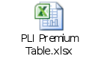

PLI Premium Table For Yugal Suraksha (Appendix – 6)

Term 10 Years
Husband Age = 30 Years
Wife Age = 25 Years
Difference Age = 5 Years
Addition to be made to lower age as per table = 3
Age at entry = 25+3 = 28 Years
Tabular premium = 93
Monthly per 10,000 SA
Premium for 90,000 SA = ((90000/10000)*93) = 837
Sum Assured Rebate = 40000: Re. 1
90000 – 40000 = 50000
(50000/10000) = 5
Total SA Rebate = (5+1) = 6
Monthly premium = 837 – 6 = 831
Quarterly premium = (831*3) – (831*(2/100))
= 2493 – 16.62 = 2476.38
Half yearly premium = (831*6) – (831*(10/100))
= 4986 – 83.1 = 4902.90
Yearly = (831*12) – (831*(50/100))
= 9972 – 415.50 = 9556.50

- ULIP
Premium (For Traditional Plans)
Add:
- Investment Amount
- Administration Charges
- Flat fee
- Fund Management Charges
Duties and Taxes = Total Amount Payable
Note: No tables for ULIP
Top up:
If Top Up Premium < ULIP Premium X 25%
Add:
- Investment Amount
- Administration Charges
- Flat fee
- Fund Management Charges
Duties and Taxes = Total Amount Payable
If Top Up Premium > ULIP Premium X 25%
ULIP Premium – (ULIP Premium X 25%)
Add:
- Investment Amount
- Administration Charges
- Flat fee
- Fund Management Charges
Duties and Taxes = Total Amount Payable

RPLI Premium Table: (Appendix – 7)
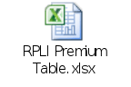

- ULIP
Premium (For Traditional Plans)
Add:
- Investment Amount
- Administration Charges
- Flat fee
- Fund Management Charges
Duties and Taxes = Total Amount Payable
Note: No tables for ULIP
Top up:
If Top Up Premium < ULIP Premium X 25%
Add:
- Investment Amount
- Administration Charges
- Flat fee
- Fund Management Charges
Duties and Taxes = Total Amount Payable
If Top Up Premium > ULIP Premium X 25%
ULIP Premium – (ULIP Premium X 25%)
Add:
- Investment Amount
- Administration Charges
- Flat fee
- Fund Management Charges
Duties and Taxes = Total Amount Payable

DEPARTMENT OF POSTS
MINISTRY OF COMMUNICATIONS & IT
GOVERNMENT OF INDIA

System Requirements Specification (SRS) for Commutaion and Reduce paid up
Non Forfeiture Options

Submitted by
Document Name | SRS_PAS_006_NFO | Version Rev. | 2.0
Document Owner | AnshuKumari | Date | 13.11.2025
Approved by

Table of Contents

1. Overview 4
1.1 Brief Description 4
1.2 Users of this Document 4
1.3 Acronym/Abbreviation 5
1.4 Non Functional Requirements 5
2. Use case-Activity Diagram 6
2.1 Reduced paid up Use case-Activity Diagram: 6
2.2 Commutation Use case-Activity Diagram: 8
2.3 Missing Requirement Use case-Activity Diagram 10
3. Assumptions 12
4. Requirements 12
5. Out of Scope/Deferred 14
6. In-Scope 14
7. Functionality Description 14
8. Functional Specification 15
8.1 Business Logic- Need to be built in product setup 15
8.1.1 Products Applicable 18
8.1.2 PSWD Mock Up Screen 20
8.1.3 PSWD Field Properties Navigation: Transaction Menu- Reduced Paid Up 23
8.2 Work Flow 32
9. References 42
10. Reports/Interfaces Interfaces 43
11. Letters 43
12. Issues/Queries 44

Overview

Brief Description

A Policy holder holding a policy other than an Anticipated Endowment Assurance and 10 year Rural PLI policy may atany time apply for reduction of his monthly premium and sum assured without altering of class his policy, or after payment of premium for not less than three years he may apply to have his policy made paid up for a reduced sum assured free from further payment of premium the paid up value of any policy will be the amount bearing of the total sum assured the same proportion as the total period for which premium have been paid bears to the maximum period for which premia where originally payable. paid up policies will not attract bonus with effect from the date of discontinuance of premium. Proportionate bonus shall however be paid on paid up value after completion of 5 years i.e. if a policy remains enforce at least for 5 years
Expectation - the above Rule regarding the amount of the paid up policy does not apply to the following cases:-
- Where there are arrears of premiums, and
- Where there is any outstanding loan or interest due.
- Commutation of future premiums by payment of a lumpsum may be permitted at any time.
- In the case of policies other than Joint Life Assurance, Children Policy, Anticipated Endowment Assurance policies and 10 year Rural PLI, conversions involving alteration of policy terms other than reduction discontinuation or commutation of premia referred to above will be allowed only after payment of premia for an integral number of years and in any case where it is intended to extend the premium term or to defer the maturity date, on the production of a medical certificate of good health at the expense of the assured. Such conversions will be permitted only once on the duration of each policy without a fee. Second and subsequent conversions shall be subject to a small fee not exceeding Rs. 20/- or as may be fixed by the Department, in each case.
- No alteration from Anticipated Endowment Assurance and 10 Year Rural PLIpolicy to other classes of policies or vice versa, or alteration in the selected term or in the sum assured of the Anticipated Endowment Assurance policy and 10 Year Rural PLI policy will be allowed.
- No such conversion of a policy as would put up the date of maturity or of cessation of premium to date preceding or with one year from the date of conversion is admissible.
The purpose of this business specification is to outline the business requirements necessary to support India Post’s (IPO) Non Forfeiture Options processing and commutation process & logic applicable to each product.

Users of this Document

- Development Team
- Testing Team
- IBU team
- India Post

Acronym/Abbreviation

Acronym / Abbreviation | Definition
PLI | Postal Life Insurance
IBU | India Business Unit
SRS | System Requirement Specification
CPC | Central Processing Centre
ECMS | Enterprise Content Management System
LMS | Lead Management System
CSR | Customer Service Representative
PMG | Post Master General
UW & RI | Underwriting & Reinsurance
DOC | Disbursing Officer’s Certificate

Non Functional Requirements
Non-functional requirements are captured in detail in Non-Functional SRS.
The following non-functional parameters should be considered while executing this functionality:

Security: The access rights for CSR and Approver shall be different

Use case-Activity Diagram

Reduced paid up Use case-Activity Diagram:

Use case ID | 01
Use case Name | Reduced Paid Up Use Case – Activity Diagram_ DoP_SRS_PAS_006_NFO_01
Use case title | Reduced Paid Up Use Case – Activity Diagram
Objective/ Purpose | To make the policy status to reduced paid up
Assumption | Due date and Grace Period has elapsed and premiums have not been paid.
Initiating Actor | Customer
Initiating Event | Customer applies for reduced paid up
Pre-conditions | The policy has acquired paid up value
Post-conditions | Reduced paid up request processed successfully
Associated Use case | Missing Requirement Use case-Activity Diagram
Error/Success conditions | Reduced paid up request processed successfully
Frequency | Whenever a reduced paid up request is submitted at Post Office/CPC/Portal
Criticality | Major – Critical activities in the overall functionality of the system
Risk | Nil

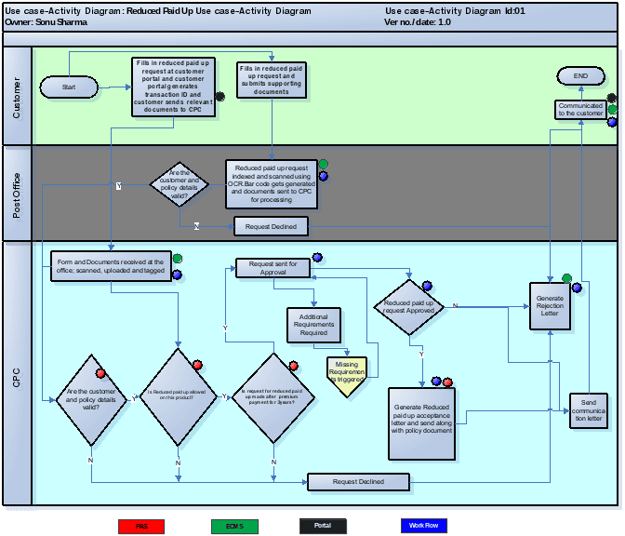

Commutation Use case-Activity Diagram:

Use case ID | 02
Use case Name | Commutation Use Case – Activity Diagram_ DoP_SRS_PAS_006_NFO_02
Use case title | Commutation Use Case – Activity Diagram
Objective/ Purpose | To process request for decrease in premium amount or sum assured
Assumption | Policy is in active status and premiums are paid regularly
Initiating Actor | Customer
Initiating Event | Customer applies for commutation
Pre-conditions | The policy is in active status
Post-conditions | Commutation request processed successfully
Associated Use case | Missing Requirement Use case-Activity Diagram
Error/Success conditions | Commutation request processed successfully
Frequency | Whenever a commutation request is submitted at Post Office/CPC/Portal
Criticality | Major – Critical activities in the overall functionality of the system
Risk | Nil

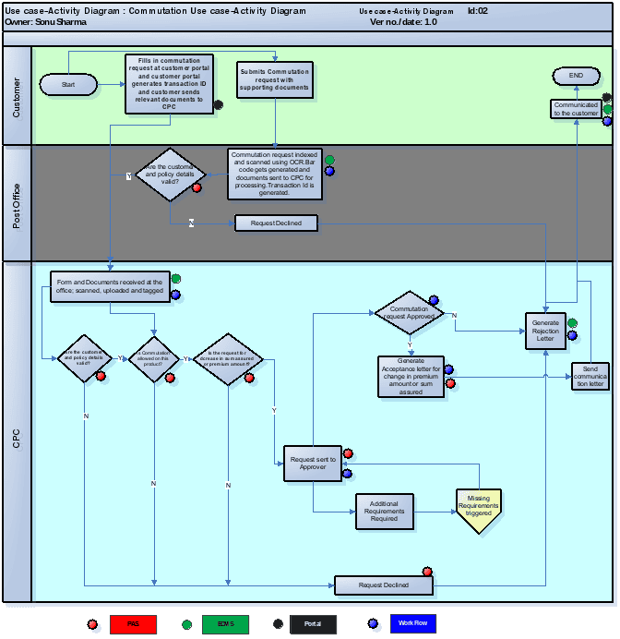

Missing Requirement Use case-Activity Diagram
Use case ID | 03
Use case Name | DoP_UseCase-Activity Diagram_SRS_PAS_006_NFO_03_ Missing Requirement
Use case title | Missing Requirement
Objective/ Purpose | Essential: To cater the missing requirements associated with the Reduced paid up/commutation request
Assumption | None
Initiating Actor | Approver
Initiating Event | Approver identifies if any requirements are missing before a request is approved.
Pre-conditions | There are a few missing requirement identified while processing the request
Post-conditions | Missing requirement have been received
Associated Use case | Commutation Use Case – Activity Diagram_ DoP_SRS_PAS_006_NFO_02  Reduced Paid Up Use Case – Activity Diagram_ DoP_SRS_PAS_006_NFO_01
Error/Success conditions | Missing requirement received is success condition
Frequency | Whenever a missing requirement is needed for processing the request
Criticality | Major – Critical activities in the overall functionality of the system
Risk | High

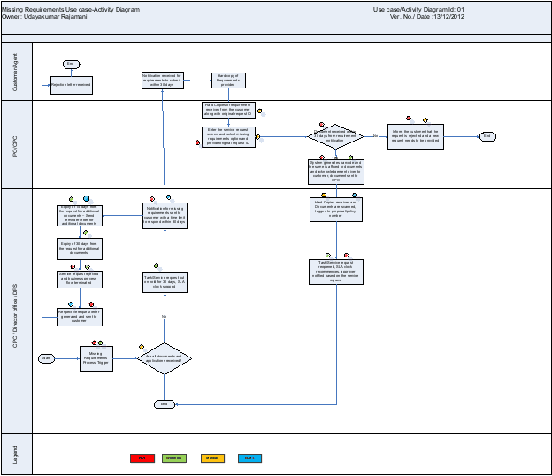

Assumptions
This business specification is written based on requirements provided in the India Post RFP document. Any product features not identified in this document requiring development may require completion of a Project Change Request.

Requirements

Requirements contained in RFP and implicit requirements from POLI document of India Post have been listed below
RFP Req No. | Requirement Description |  | Solution | Section of SRS covering Solution
 | Product set up requirements for NFO & Commutation
PI A.8 | Must show the policy status as on a given date (New Business, Pending for enforcement, Inforce, Lapsation, Paid up, Terminated, Matured, Death Settlement notified, Death Settlement pending) |  | Policy status as on a given date can be viewed in policy summary and detailed summary pages. Policy status will show all the policy status requested for and additionally reduced paid up Status as well. | 8.1
PI A.16 | In case of policies which have been in force for more than XX months. It must change the policy status from inforce to paid up on expiry of XXX days from the premium due date, in case of non-receipt of premium. |  | In case of policies which have been in force for more than 36months the policy status is changed from Active to Paid-up on expiry of 12months which will be handled in batch process. Number of months mentioned here is configurable 12 months to be considered instead of 365days.(As per DoP’sinput during BPD on 09/11/2012) | 8.1
PI A.35 | Shall have the functionality that on a policy being enforced, any change in the DOB, Annual Premium, Sum Assured and product post enforcement shall result in cancellation of the existing policy. |  | Policy cancellation condition will be added by creating a new module for termination for the specified conditions. Conflicting requirement like reduced paid-up, commutation, conversion, etc. can be handled as an exception for triggering this functionality.  In case the policyholder has paid more premiums due to DOB being more than actual DOB submitted subsequently then DoP does not refund the excess premium paid. But if the premium payment is less than what was required then the same is collected from Policy Holder.  DoP would inform the user level who would be able to approve the changes as cited in PI A.35. In a scenario where excess premium has been collected due to DoP's fault then the excess premium will be adjusted towards future premium.  Change in DOB whether allowed or not needs to be decided. Decision on cancellation of policy post change in DOB is deferred. | Change in DOB not allowed as decision taken by PLI Directorate (Comments from 25/01/2013 meeting)
PI A.38 | Need to support Non Forfeiture option set up for Participating products (after 3 years) |  | DoP currently supports only reduced paid-up NFO option. Reduced paid up screen has been provided in PAS. | 8.1
PI A.43 | Should allow increase or decrease of Sum Assured/benefits if product set up permits. Conversion of products should be allowed by the system, after minimum conversion requirements are fulfilled. |  | Commutation is allowed in some products which is covered in Business logic part.  Increase in Sum Assured allowed only at proposal stage within 60 days from the date of application. DoP only wants increase in sum assured till proposal is not converted. Thereafter it will be a new proposal.  This is based on the PIC MOM dt. 2812012  Conversion of products covered in SRS_PAS_001_Policy Administration | 8.1
PI A.65 | No Decrease of Sum Assured allowed once policy commences |  | Decrease of sum assured is not allowed on Sumangal Gram Sumangal and Gram Priya | 8.1
Accounting requirements for NFO
PI A.106 |  | In case of a policy becoming paid up it must automatically pass the predefined entries | Covered in SRS__AC_001_Transaction code and Accounting Management

Out of Scope/Deferred
Call Centre requirements, Customer Portal requirements are out of scope for this SRS. Any products from India Post other than the products in scope that are mentioned below are out of scope.

In-Scope
Commutation and Non Forfeiture options process for DoP PLI products.
Following PLI products are in scope:

PLI/RPLI | Product Name | Product Type
PLI | Suraksha | Whole Life Assurance
PLI | Santosh | Endowment Assurance
PLI | Suvidha | Convertible Whole Life Assurance
PLI | Sumangal | Anticipated Endowment Assurance
PLI | Child Policy | Child Policy
PLI | Yugal Suraksha | Joint Life Assurance
RPLI | Gram Suraksha | Whole Life Assurance
RPLI | Gram Santosh | Endowment Assurance
RPLI | Gram Suvidha | Convertible Whole Life Assurance
RPLI | Gram Sumangal | Anticipated Endowment Assurance
RPLI | Child policy | Child policy
RPLI | Gram Priya | Anticipated Endowment Assurance
ULIP | ULIP | A sample ULIP that is being setup for India Post

Functionality Description

Non Forfeiture Option: Non forfeiture benefits are the options which provide that even if the owner fails to pay the policy premium and it lapses after a specific period, the insured or policy owner gets benefits as specified choice of NFO
India Post supports only one type of Non Forfeiture option for their products which is Reduced Paid-Up (RPU).
Commutation: Commutation means alteration in the terms of insurance contract including change in premium amount or sum assured. It excludes changes in the date of maturity of the contract as specified in POLI rules of DoP.

Functional Specification

Business Logic- Need to be built in product setup

 | Non-Forfeiture Options | System rule to be built
When allowed | The policy must be inforce for minimum 36months from date of inception and, premium should have been paid regularly on the same.  Policy Status should be Lapse. | Policy Status= Lapse  Premium Paying Term=36months.  Policy Year since inception=3years
Form(s) Required | Checklist for mandatory document to be built :  Policy Bond  Premium Receipt Book  D.O.C( Disbursing Officer’s Certificate ) for last one year in case of Pay Recovery | ECMS will store the scanned documents.  Checklist of Received documents will be built in the system.
Paid Up Value | (No. of premium paid/Total no. of premium payable)*Sum assured  Paid up value for intermittent premium gaps : Paid up value = Number of premium paid/Premium payable * SA - Premium + interest + Bonus(if applicable)  Paid up value in case of outstanding loan : Paid up value = Number of premium paid/Premium payable * SA – Outstanding loan amount+ interest + Bonus(if applicable) | The rule will be built in product set up for Different products.  If the paid up value is less than Rs.10,000 then the policy is foreclosed and amount returned to the customer.  Bonus is applicable only in case the policy term is greater than 5years.  Bonus in case of paid up value is calculated on the reduced sum assured and not the original sum assured.
Auto Paid up | If no application is received then the policy will be automatically kept alive only to the extent of its paid up value provided such paid up value is not less than Rs.10,000/- | The rule will be built in product set up for Different products
Status Change | In case of a policy which has been in force for >3years the policy will become lapsed after a period of 12months from the date when the first unpaid premium has become due | The rule will be built in product set up for Different products
Foreclosure of policy | If paid up value is <10000 the said amount will be disbursed and the policy foreclosed | The rule will be built in product set up for Different products
Exceptions | In case of Anticipated Endowment assurance & Gram Priya the reduced paid up assurance will be granted only at the date of maturity or on death of life assured provided premiums have been paid for >3 years | The rule will be built in product set up for these products.
Exceptions | In case of non-payment of premium Anticipated Endowment assurance & Gram Priya the periodical payment on account of survival benefit will stop | The rule will be built in product set up for these products.
Agent Commission | Agent will not receive commission on paid up policy in future. | Details of the logic will be built in Agency management system.
Bonus | <5 yrs policy age - Nil  - > 5 yrs policy age - proportionate to the reduced sum assured | Need to setup rule during Product setup
Bonus calculation on paid up amount | (Bonus rate*Paid Up value)/1000 Details in Bonus SRS | Need to setup rule during Product setup
Error code | When the transaction is processed successfully in the batch cycle the error code will change to 0000. | (will be changed to success code)
 | Commutation | System rule to be built
When Allowed | Commutation may be allowed any time.  Policy status should be Active. | Policy Status=AP(Active Premium )
Form(s) Required | Checklist for mandatory document to be built :  Policy Bond  Premium Receipt Book  D.O.C ( Disbursing Officer’s Certificate ) for last one year in case of Pay Recovery | ECMS will store the scanned documents.  Checklist of Received documents will be built in the system.
Agent Commission | Agent’s commission will be impacted due to changes in premium amount & changes in sum assured. | Details of the logic will be buit in Agency management system.
Regulatory Authority | Guidelines from Government of India from time to time
Lump sum payment of premium | Commutation of future premiums by payment of a lump sum may be permitted at any time. | Formula for the calculation of the lump sum amount to be built during Product setup  Note: This is covered in Billing & Collection SRS
Change in premium amount | Policy holder can any time change his premium amount | Need to setup rule during Product setup. Increase in Sum Assured/premium amount allowed only at proposal stage within 60 days from the date of application. DoP only wants increase in sum assured till proposal is not converted. Thereafter it will be a new proposal.
Change in sum assured | Policy holder can any time change his sum assured | Need to setup rule during Product setup  Increase in Sum Assured allowed only at proposal stage within 60 days from the date of application. DoP only wants increase in sum assured till proposal is not converted. Thereafter it will be a new proposal.
Rebate | The policy holder gets rebate @1% of total premium paid for at least 6 months and @2% for 12 months. Such rebate is applicable only for advance premium paid in multiples of 6 months. | The rule will be built in product set up for these products.  Note: This is covered in Billing & Collection SRS
Exceptions | Commutation is not allowed on Anticipated endowment assurance and Gram Priya | The rule will be built in product set up for these products.
Minimum Sum Assured allowed for PLI & RPLI products | PLI Minimum SA  Suraksha 20,000  Santhosh 20,000  Suvidha 20,000  Sumangal 20,000  Yugal Suraksha 20,000  Children Policy 20,000  RPLI  Gram Suraksha 10,000  Gram Santhosh 10,000  Gram Suvidha 10,000  Gram Sumangal 10,000  Gram Priya 10,000  CHILDREN POLICY(RPLI) 10,000 | The rule will be built in product set up for the specific products.  In case of Commutation (decrease in Sum Assured/premium amount) the sum assured should not be less than the specified minimum amount after change in sum assured/premium amount.

Products Applicable
PLI Products
Product Type | Product Name | Non-Forfeiture Option Available (Y/N) | Commutation Available  (Y/N)
Whole Life Assurance | Suraksha- Whole Life Assurance | Yes, after premium payment of 3yrs | Yes
Endowment Assurance | Santosh-Endowment Assurance | Yes, after premium payment of 3 yrs | Yes
Convertible Whole Life Assurance | Suvidha - Convertible Whole Life Assurance | Yes, after premium payment of 3yrs | Yes
Endowment Assurance | Sumangal - Anticipated Endowment Assurance | Reduced Paid Up only at the time of maturity or on death of life insured | No
Endowment Assurance | Child Policy | Yes, after premium payment of 3yrs | Yes
Endowment Assurance | Yugal Suraksha - Joint Life Assurance | Yes, after premium payment of 3 yrs | Yes

RPLI Products
Product Type | Product Name | Non Forfeiture Option Available (Y/N) | Commutation Available  (Y/N)
Whole Life Assurance | Gram Suraksha- Whole Life Assurance | Yes, after premium payment of 3yrs | Yes
Endowment Assurance | Gram Santosh-Endowment Assurance | Yes, after premium payment of 3 yrs | Yes
Convertible Whole Life Assurance | Gram Suvidha - Convertible Whole Life Assurance | Yes, after premium payment of 3yrs | Yes
Endowment Assurance | Gram Sumangal - Anticipated Endowment Assurance | Reduced Paid Up only at the time of maturity or on death of life insured | No
Endowment Assurance | Child Policy | Yes, after premium payment of 3yrs | Yes
10 year Rural Anticipated Endowment Assurance | Gram Priya- Anticipated Endowment Assurance | Reduced Paid Up only at the time of maturity or on death of life insured | No

PSWD Mock Up Screen
The screens mentioned here are just indicative and the logo visible in the screen shot will be replaced by the below logo in the system to be delivered to DoP

Reduced Paid up Tab will be added under Transactions menu - Reduced Paid Up will be added in the dropdown for Type of Request.
This Tab will have Quote and Process buttons for the user to choose the specific action.
Commutation Tab will be added under Transactions menu - Commutation will be added in the dropdown for Type of Request.
Policy Indexing Screen:
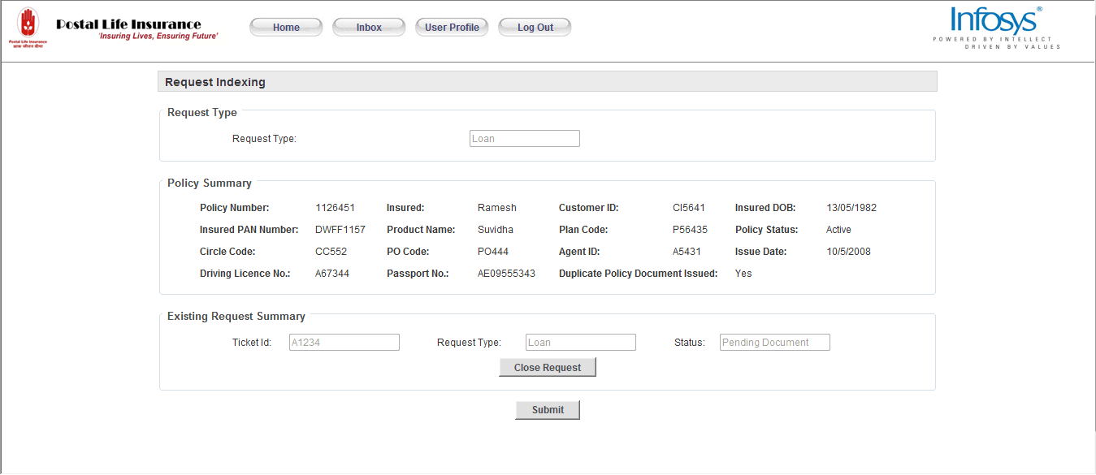

PSWD Mock up Screens for Reduced Paid up:
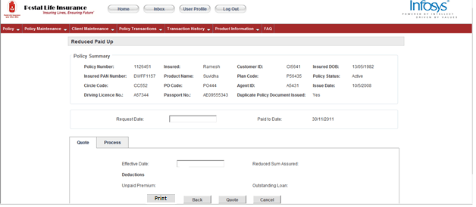

On clicking quote:
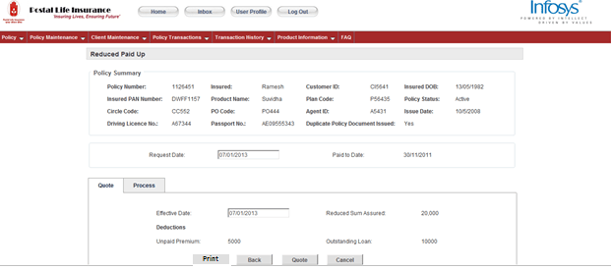

On clicking process tab

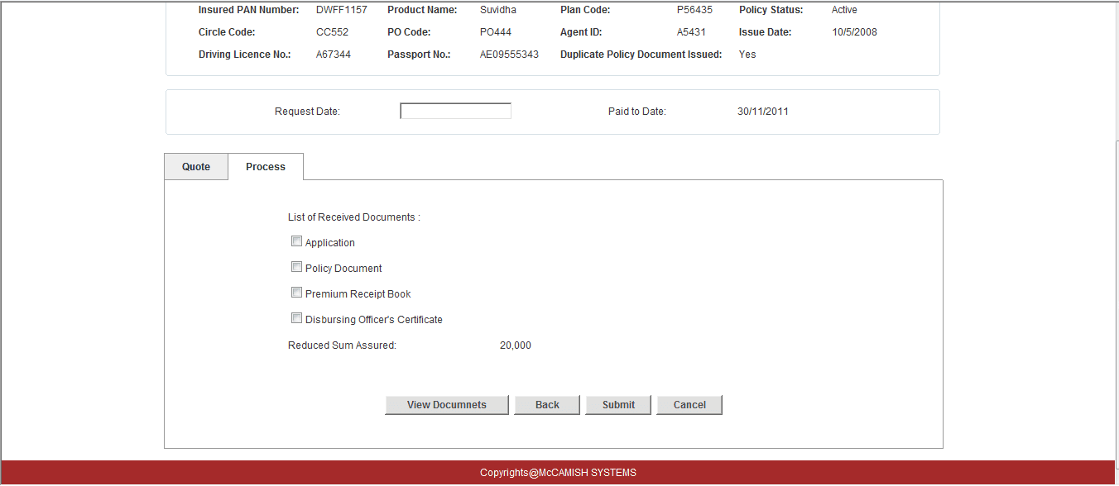
On clicking ‘Submit’ the request is sent for Approval
Approval Screen:
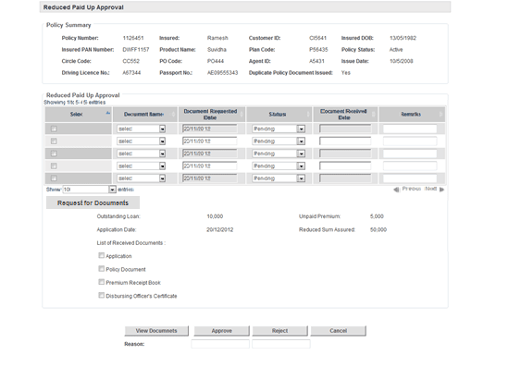
Auto Paid Up:
On non-receipt of an application from the policy holder for reduced paid up the policy status will be automatically changed to Paid up after 12months from the date when the first unpaid premium has become due.
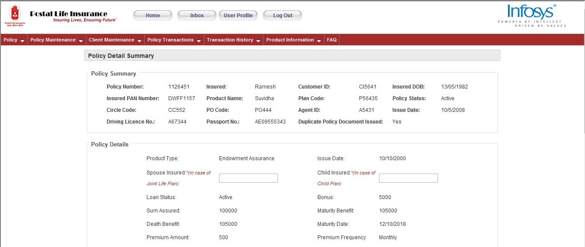

8.1.3 PSWD Field Properties
Navigation: Transaction Menu- Reduced Paid Up
Users: Branch Customer Executive,CSR,Call Centre Executive,PMG
PSWD Field Name | Display | Field Value | Corresponding VPAS Screen | Corresponding VPAS Field | Comments
On PSWD Header | Section |  |  |  | These fields are common fields and will be displayed on header of PSWD
Policy Number | Text, Alpha numeric ,15 characters | Read only field policy number | Cell-more-events-fixed premium Reduced paid up(RPU) | Policy Number
Policy Holder Name: | Text, | Read only field Policy Owner Name | Cell-more-events- fixed premium Reduced paid up(RPU) | Policy Holder Name:
Policy Status | Text, | Read only field  Available status:   | Cell-more-events- fixed premium Reduced paid up(RPU) |  | The current policy status will be displayed
Product Name | Text, | Read only field, Product of the policy to be serviced
Product Code |  | Read only field, Product of the policy to be serviced
Issue Date | Date- DD/MM/YYYY | Policy Issue Date | Cell-more-events- fixed premium Reduced paid up(RPU) | Effective Date:
Paid-to-Date | Date:DD/MM/YYYY | Date till which the premium has been paid
Request Date: | Date- DD/MM/YYYY | Date on which Reduced paid-up Request is processed | Cell-more-events- fixed premium Reduced paid up(RPU) | Event Date
Outstanding Loan | Numeric Value | Outstanding loan value in Rs. | Cell-more-events- fixed premium Reduced paid up(RPU) | Loan Balance
Unpaid Premium | Numeric Value | Unpaid Premium value in Rs.
Quote | Button | Will fetch the Reduced sum assured value after deductions | Cell-more-events- fixed premium Reduced paid up(RPU) | Quote button | On clicking Quote button, reduced sum assured value will appear
Process | Button | Will open a reduced sum assured window |  |  | A new reduced sum assured window will open which will contain the reduced sum assured specific detail.
Reduced sum assured | Numeric Value | Reduced sum assured Value in Rs. | Cell-more-events- fixed premium Reduced paid up(RPU) | Reduced paid up (RPU) Face Amount
Submit | Button | Must be enable for below products:  PLI - Suraksha, Suvidha,Santosh,YugalSuraksha,Child Policy  RPLI - Gram Suraksha, Gram Suvidha,GramSantosh,Child Policy  Enable for Santosh and Gram Santosh products on completion of 3 policy years  Enable for Suraksha,Suvidha,Gram Suraksha and Gram Suvidha on completion of 4 policy years  Enable for child policy(urban & rural) on completion of 5 policy years  Enable when Submit for Approval Check box is checked. | Cell-more-events- fixed premium Reduced paid up(RPU) | Submit

PSWD Mock Up Screens Commutation:
Request Indexing:
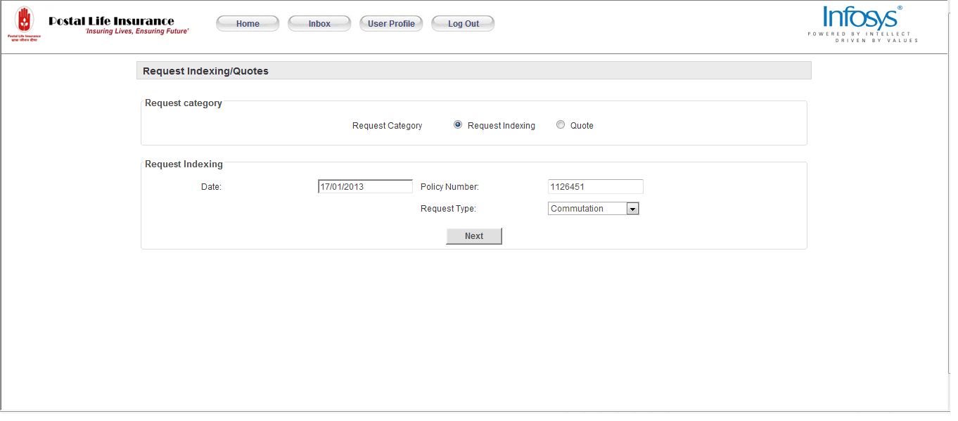

Navigation: Transactions->Commutation
On clicking commutation following screen will appear
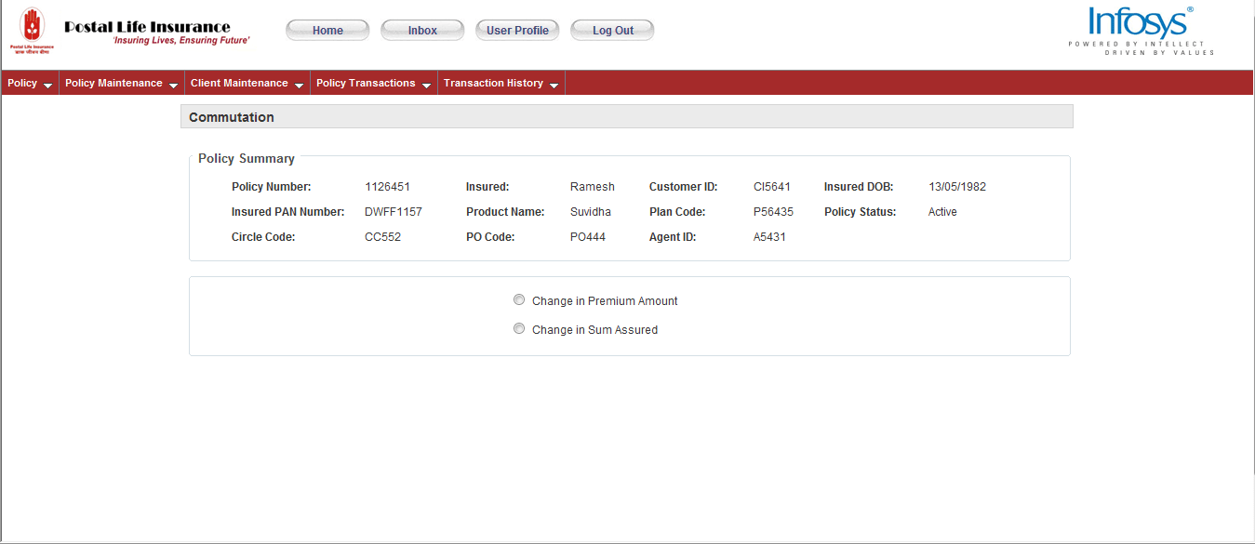

Change in premium amount
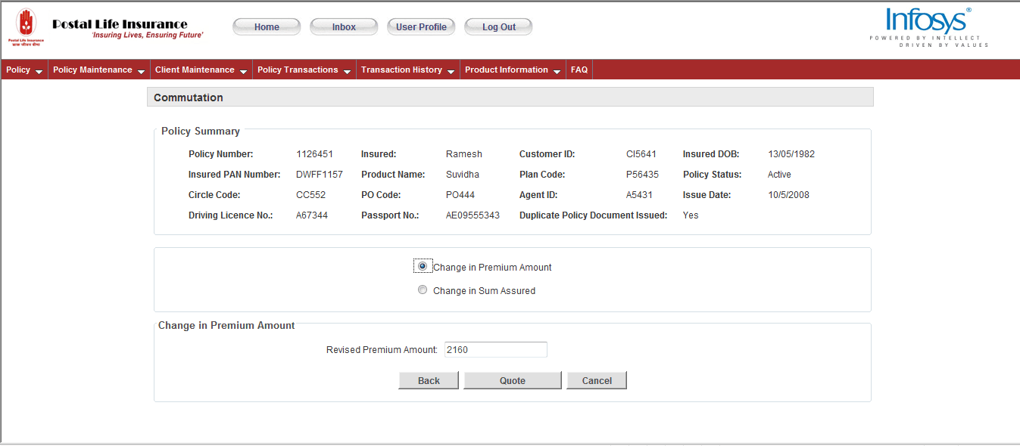

Click Quote:
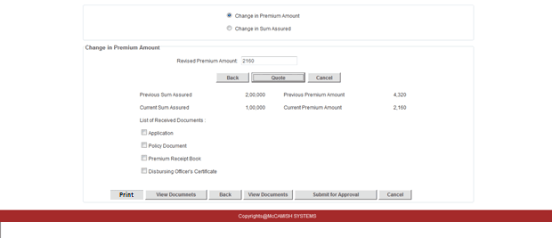

On clicking Submit for Approval:
The request will be sent to Approver

Approval Screen:
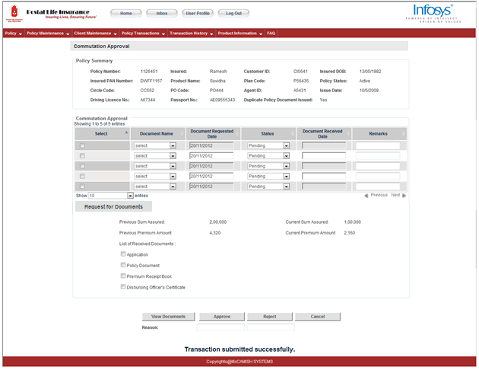

Change in Sum Assured:
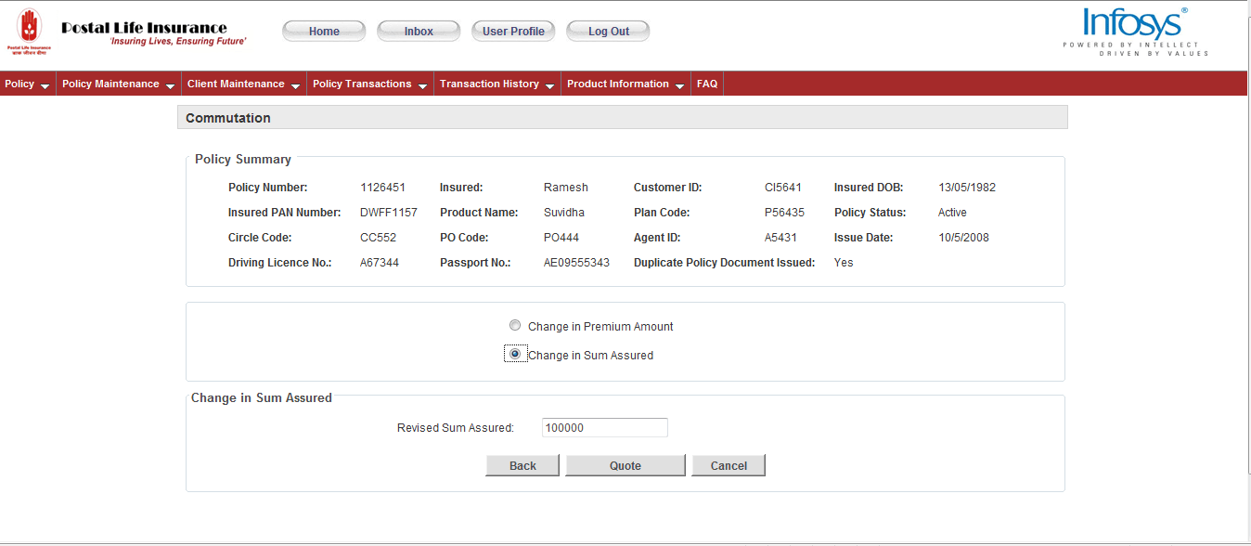

Click Quote:
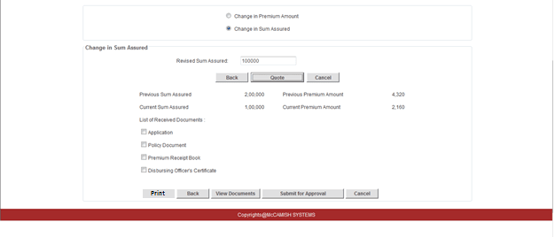

On clicking Submit for Approval:
The request will be sent to Approver:
Approval Screen:

Navigation: Transaction Menu- Commutation
Users: Branch Customer Executive, CSR, Call Centre Executive,PMG
PSWD Field Name | Display | Field Value | Corresponding VPAS Screen | Corresponding VPAS Field | Comments
On PSWD Header | Section |  |  |  | These fields are common fields and will be displayed on header of PSWD
Policy Number | Text, Alpha numeric ,15 characters | Read only field policy which will be serviced | Cell-more-coverage | Policy Number
Policy Holder Name: | Text | Read only field Policy Owner Name | Cell-more-coverage | Policy Holder Name:
Policy Status | Text | Read only field  Available status: | Cell-more-coverage |  | The current policy status will be displayed
Product Name | Text | Read only field, Product of the policy to be serviced
Product Code |  | Read only field, Product of the policy to be serviced
Paid-to-Date | Date: DD/MM/YYYY | Date till which the premium has been paid
Request Date: | Date- DD/MM/YYYY | Date on which Commutation Request is processed | Cell-more-coverage | Event Date
Sum assured | Numeric Value | The new sum assured will be entered here | Cell-more-coverage | Face amount
Previous sum assured | Numeric value | The old sum assured will be displayed | Cell-more-coverage | Face amount
Previous premium amount | Numeric value | The old premium amount will be displayed | Cell-more-cell summary-billing summary | Premium
Current Premium amount | Numeric Value | The new premium amount will be entered here | Cell-more-cell summary-billing summary | Premium | The changed premium amount will be displayed

Work Flow

Generic Rules
- Inbox of the User will be populated with that assigned Work as per the role.

User Inbox
- Inbox of the users will provide the task/applications assigned to them.
- Sorting of the applications can be done on the basis proposal Status provided on Left Pane.
- On Click of Submit Button, user is taken to the application on that particular screen where his action is required.
- Even the Task page will display the applications which are required to be attended.
- Alerts display the tasks which require instant attention.

Inbox :

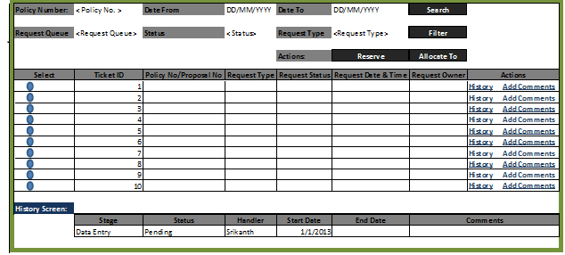

The following are the properties of above screen:
Sr. No | Field Name | Data Type/ Format | UI Display | Properties | Comments | Mandatory Fields
1 | Policy Number: |  | Label | Text
2 | < Policy No.> | Numeric | Text box | Enabled | Length of this field should be of 13 byte.
3 | Date From |  | Label | Text
4 | DD/MM/YYYY | Date | Date | Enabled | When user clicks / enter here, the current calendar month should pop-up, where user can select the date.
5 | Date To |  | Label | Text
6 | DD/MM/YYYY | Date | Date | Enabled | - When user clicks / enter here, the current calendar month should pop-up where user can select the date.  - This date should be smaller than the DATE FROM date, if entered date is greater than DATE FROM, system should pop-up a message “Please enter the correct date” having the push-up button as “OK”. If user clicks on the OK button, the entered date should be erased and cursor should point to the same field again.
7 | Search |  | Pushbutton | Enabled | When user enters a valid policy number or a date range, and push the search button, system should display the available records.  NOTE: -  Scenario 1:  - System should allow to enter a valid policy number keeping the date range blank.  - If entered policy number is incorrect, a pop-up message should appear stating "Please enter the correct Policy Number" having push button as OK. If user clicks on OK button, system should reallow to enter the policy number.  Scenario 2:  - System should allow to enter a valid date range keeping the policy number blank.  - If there are no policies in the specified date range, a pop-up message should appear as “No policies exist in the specified date range, do you want to change the date range” and two push button as “OK” & “Cancel”. If user selects OK, system should clear the DATE FROM and DATE TO and cursor should point on DATE FROM. On selecting the Cancel button, cursor should point to Policy Number field.  Scenario 3:  - System should allow to enter the valid policy number along with the valid date range to complete the search criteria.  - System will first check whether the entered policy lie in the date range specified. If so, system will populate the policy else, a message should appear as “Entered policy do not exist in the specified date range, please verify the policy number and date range” and there should be an “OK” button on the pop-up. If user clicks on the OK button, cursor should go back to policy number text.
8 | Request Queue |  | Label | Text
9 | <Request Queue> | Type code | Dropdown | Enabled | User should be able to select any of the option available from the dropdown list.  - Pending for Data entry  - Pending for documents  - Pending for Quality Check  - Pending for Approval  - Pending for Underwriting  - Pending for Investigation  - Pending for Claim approval  - Pending for Disbursement
10 | Status |  | Label | Text
11 | < Status> | Type code | Dropdown | Enabled | User should be able to select any of the option available from the dropdown list.  1. Pending  2. Reserved  3. Completed  4. Rejected  5. Cancelled  6. Terminated  7. Failed
12 | Request Type |  | Label | Text
13 | <Request Type> | Type code | Dropdown | Enabled | User should be able to select any of the option available from the dropdown  - Proposal  - Status Request  - Loan  - Death Claim  - Duplicate Policy Bond  - Duplicate Premium Receipt  - Freelook Cancellation  - Revival/Reinstatement  - Reduced Paid up  - Commutation  - Surrender  - Partial Withdrawal  - Name/Address Change  - Assignment/Re-assignment  - Change of Nomination  - Conversion  - Switches/Re-direction  - Billing Changes  - Missing Requirements Documents
14 | Filter |  | Pushbutton | Enabled | - After selecting ANY of the dropdown list mentioned above, if user press the push button, the available records should be displayed.  - System should allow to put filter even if there is only one of the three options get selected.  - After selecting from the drop down, and clicking the Filter button, if there is no records, a pop-up message should appear as “There is no record exist” with a push-up button as “OK”.
15 | Actions: |  | Label | Text
16 | Reserve |  | Pushbutton | Enabled | - After selecting the record (radio button), user can assign the selected task to him.  - If the task is already assigned/reserved, a pop-up message should appear as “Task is already assigned/reserved, please select another task” and there should be “OK” button. When user selects the OK button, pop-up should disappear.
17 | Allocate To |  | Pushbutton | Enabled to supervisor only | - This button should be available to the person, who is logged in as supervisor.  - Supervisor should be able to assign the selected task to himself as well as any of his subordinates.  - If the task is already assigned / reserved, a pop-up message should appear as “Task is already assigned/reserved, please select another task” and there should be “OK” button. When user selects the OK button, pop-up should disappear.
18 | Select |  | Radio button | Radio button | Contents under this label should be radio button.
19 | Ticket ID |  | Label | Text | Under this label, a unique number is assigned to each task created.
20 | Policy No/Proposal No |  | Label | Text | This label will contain the policy number / proposal number for the task created.
21 | Request Type |  | Label | Text | This is the type of request raised.
22 | Request Status |  | Label | Text | This is the current status of request raised.
23 | Request Date & Time |  | Label | Text | This is the date & time of request raised.
24 | Request Owner |  | Label | Text | - When a user reserve a case for himself, in that case, the user’s name will be populated here.  - When supervisor assign the case to any subordinate, in that case, subordinate’s name will populate here.
25 | Actions |  | Label | Text | On clicking on the below 2 links available, user can either view history or can add the comments.
26 | History |  | Link | Text | - When user clicks on this link, HISTORY Screen pane should appear.  - If there is no history for any particular task, a pop-up should appear as “There is no History Record” and there should be an “OK” button on the pop-up. When user selects the OK, pop-up should disappear.
27 | Add Comments |  | Link | Text | When user clicks on this link, ADD COMMENTS pane should appear.
28 | History Screen: |  | Label | Text | This Pane appears only when user clicks on the above HISTORY link.
29 | Stage |  | Label | Text | The correct stage should appear below this label.
30 | Status |  | Label | Text | The correct request status should appear below this label.
31 | Handler |  | Label | Text | The correct owner should appear below this label who is working on this task.
32 | Start Date |  | Label | Text | This is the date on which any task is assigned with a specific activity or put on into particular stage.
33 | End Date |  | Label | Text | This is the date on which a task gets completed from a particular stage and moved into other stage.
34 | Comments |  | Label | Text | This will show any comments added to the policy / proposal.
35 | Add Comments: |  | Label | Text | This Pane appears only when user clicks on the above ADD COMMENTS link.
36 | <Comments Free Text> | Alphanumeric | Free Text | Enabled | This should be a free text to enter the comments. | Yes
37 | Submit |  | Pushbutton | Enabled | After entering the comments, when user clicks on this button, comments should be stored in history records.
38 | Cancel |  | Pushbutton | Enabled | If user clicks on the cancel button, ADD COMMENTS pane should disappear.
39 | Allocate To User |  | Label | Text | This Pane appears only when user (supervisor) selects any item (Radio button) from the available task and clicks on the above ALLOCATE TO button provided on the top.
40 | <Drop Down user> | Type code | Dropdown | Enabled | After appearing this pane, drop down button should appear having the name of all those users, who are the subordinates of the particular supervisor. | Yes
41 | Submit |  | Pushbutton | Enabled | After selecting the user from the drop down list, when user (supervisor) clicks on the SUBMIT button, the selected task should be assigned to the correct person and it should be viewable to the concern user.  If the selected task is already assigned / reserved by other user, a pop-up message should appear as “Task is already assigned, please try another option” followed by an “OK” button.
42 | Cancel |  | Pushbutton | Enabled | If user clicks on the cancel button, ALLOCATE TO USER pane should disappear.

References

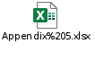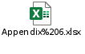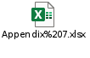
Documents
RFP
POLI Rules 2011
DoP Circle Office Manual
MoM of BPD Sessions I & II

Reports/Interfaces
Interfaces
Considerations | Interface | Impact in case of Non Forfeiture Options | Impact in case of Commutation
ECMS | Y | Letters & reports  Policy Holder documents will be scanned in the system | Letters & reports  Policy Holder documents will be scanned in the system
JBPM | Y | A new work item for every new request will be created and will be distributed to the work bucket of the branch, circle CSRs and PMG | A new work item for every new request will be created and will be distributed to the workbucket of the branch, circle CSRs and PMG
NBF | N | Nil | Nil
PMACS® | Y | Agent Commission to be stopped for Paid Up Policy(Confirm) | Agent Commission calculations to be changed for change of premium amount and sum assured
Underwriter’s Workbench | N | Nil | Nil
VPAS | Y | Paid up values and deductions will be calculated in VPAS  Policy Status change,Batch Runs | Premium amount, sum assured will be calculated in VPAS,Batch Runs
LMS | N | Nil | Nil
Finacle | Y | Nil | Nil

11. Letters

Document Number | Letter/Document Name | Brief Description
1 | Reduced paid up Approval/Rejection Letter | Communication to be sent to customer on approval/rejection of the reduced paid up request
2 | Increase in sum assured Approval/Rejection Letter | Communication to be sent to customer on approval/rejection of the increase in sum assured request
3 | Decrease in sum assured Approval/Rejection Letter | Communication to be sent to customer on approval/rejection of the decrease in sum assured request
4 | Increase in premium amount Approval/Rejection Letter | Communication to be sent to customer on approval/rejection of the increase in premium amount request
5 | Decrease in premium amount Approval/Rejection Letter | Communication to be sent to customer on approval/rejection of the decrease in premium amount request
Templates for reports and letters are covered in SRS_LR_002_Letters Reports VPAS

Issues/Queries
S.No. | Owner | Description | Additional Information/Resolution | Resolution | Status
1. |  | Is there any minimum and maximum limit to which the premium and sum assured can be altered? |  | Minimum and maximum limits as mentioned in POLI Rules 2011 | Closed
2. |  | In case of arrears of premium or in case of outstanding loans and interest how is the paid-up value calculated? |  | Formula provided by DoP during BPD sessions | Closed
3. |  | How is agent commission affected when premium amount or sum assured is changed (commutation)? |  | Communicated to the agent | Closed
4. |  | What are the predefined accounting entries that a paid-up policy must pass? |  | Covered in SRS__AC_001_Transaction code and Accounting Management | Closed
5. |  | Change in DOB whether allowed or not needs to be decided. Decision on cancellation of policy post change in DOB is deferred. |  |  | Closed.  Not required as decision taken by PLI Directorate (Comments from 25/01/2013 meeting)

